THE INFLUENCE OF SELF-CONTROL ON SPENDING BEHAVIOUR
A 20-Year Evidence Review of Consumer Behaviour, Digital Payments, Financial Well-Being and AI-Era Marketing
Emmanuel Lotirema Iko
Student, School of Management Science, Apeejay Stya University, Gurugram, Haryana, India
Dr. Manju Rani
Assistant Professor, School of Behavioural Sciences, Apeejay Stya University, Sohna, Haryana, India

Abstract
Self-control is a psychological capacity relevant to resisting immediate rewards, delaying gratification, and aligning consumption with longer-term financial goals. This paper reviews evidence on self-control and spending behaviour, with particular attention to impulse buying, cashless payments, financial well-being, financial literacy, digital commerce, and algorithmic/AI-enabled marketing. It uses a narrative evidence-review approach and secondary data from peer-reviewed meta-analyses, empirical studies, and the World Bank’s Global Findex Database. Country and regional comparisons are reported for Global Findex survey waves from 2011, 2014, 2017, and 2021. These indicators measure access to financial accounts—not self-control or impulsive spending—and are therefore used only to describe the changing financial and digital context in which spending occurs. A meta-analysis of 392 effect sizes from 71 papers found a small, statistically significant cashless effect (Hedges’ g = 0.135), while an India-specific quasi-experimental study reported that a 10-percentage-point difference in pre-demonetisation cash dependence was associated with a 2.38% increase in monthly spending after the forced shift toward digital payments. The review concludes that spending behaviour reflects interactions among self-regulation, payment salience, emotional states, financial knowledge, social context, and marketing design. Evidence does not justify treating financial inclusion, digital-payment adoption, or exposure to AI as direct measures of poor self-control. The paper proposes practical interventions and identifies the need for longitudinal, cross-country studies that measure actual spending and AI exposure directly.
Keywords: self-control; spending behaviour; impulse buying; digital payments; financial well-being; financial literacy; algorithmic marketing; artificial intelligence; Global Findex

Introduction
Impulse buying is a related but distinct construct. It usually refers to a relatively spontaneous purchase accompanied by a strong urge to buy, often with limited deliberation. Iyer et al. (2020), in a meta-analysis of 231 samples from 186 articles and 75,434 respondents, showed that impulse buying is associated with a broad set of internal and external antecedents. These include affective states, traits, situational cues, and marketing conditions. This evidence argues against a single-factor explanation.
The payment environment has changed substantially since the early 2000s. Cards, mobile wallets, instant payment systems, one-click checkout, buy-now-pay-later products, personalised recommendations, and platform notifications can reduce the friction between desire and purchase. Yet access to digital financial services can also improve inclusion, convenience, security, and resilience. The central question is therefore not whether digital payments or technology are inherently harmful, but under which conditions they change spending and whether self-regulation skills moderate those effects.
This review combines a long-term context comparison with evidence directly related to spending. It distinguishes direct findings about spending from contextual indicators such as account ownership. The distinction is important: account ownership is a financial-inclusion measure, not a behavioural measure of impulse buying or self-control.

Objectives and Research Questions
- To synthesise research on self-control, impulse buying, and financial well-being.
- To compare selected country and regional trends in financial account ownership across Global Findex waves (2011–2021).
- To summarise evidence on cashless payments and consumer spending, including India-specific evidence.
- To examine how online platforms, personalised marketing, and AI-enabled recommendations may interact with consumer self-regulation while distinguishing plausible mechanisms from demonstrated causal effects.
- To identify evidence-based strategies for consumers, educators, financial institutions, and policymakers.
Research questions: (1) How is self-control associated with spending and impulse buying? (2) What has changed in the financial/digital context across countries and regions? (3) What does empirical evidence show about cashless payments and spending? (4) What is currently established—and not established—about AI-era marketing and spending?

Review Method
This paper uses a narrative evidence-review design rather than a new systematic review or a primary-data study. Evidence was selected from peer-reviewed meta-analyses and empirical research, together with World Bank Global Findex reports and data summaries. Priority was given to sources with transparent methods, identifiable samples, effect sizes, or official country/regional indicators. The review covers foundational self-control research and more recent work on cashless payments and digital consumption, with a contextual period extending approximately 2002–2024.
The Global Findex comparison uses four survey waves—2011, 2014, 2017, and 2021—for which consistent country and regional account-ownership estimates are available in the cited sources. Account ownership is defined as the share of adults aged 15+ who report an account at a financial institution or mobile-money provider. Regional aggregates may exclude high-income economies where indicated by the World Bank. The 2024 Global Findex wave is not mixed into the main trend chart because it is a newer survey wave and should be analysed separately with its own full comparable series and source notes.
No original survey, experiment, or individual-level spending dataset was collected for this paper. Consequently, no causal claim is made from the descriptive country comparisons. AI-related discussion is conceptual and evidence-limited: recommendation systems and algorithmic targeting existed before generative AI, and the reviewed evidence does not isolate a general causal effect of generative AI on personal spending.

Literature Review

Self-control and self-regulation
Self-control can be understood as the capacity to regulate impulses, attention, emotion, and action in service of a goal. In consumer settings, this may involve delaying a purchase, comparing alternatives, setting a spending limit, or resisting a cue-triggered urge. Trait self-control, momentary self-control, and a specific spending decision are not interchangeable. A person may generally report high self-control yet make an unplanned purchase under stress or a strong situational cue.
Baumeister (2002) connected self-regulation with consumer behaviour, while Tangney et al. (2004) developed and validated a trait self-control measure. These studies provide theoretical and measurement foundations, but their findings should be combined with spending-specific evidence rather than used as a substitute for it.

Impulse buying and its antecedents
Impulse buying reflects the interaction of individual and situational influences. Iyer et al. (2020) synthesised evidence from a large body of research and found that affective, personality, situational, and marketing factors are relevant. Pick and Eisend (2014) also meta-analysed antecedents of consumer impulse buying, highlighting the value of considering multiple predictors. The practical implication is that a purchase cannot be attributed to weak self-control alone without considering context, product type, affordability, emotional state, and purchasing environment. Research focused specifically on online buying also identifies website, marketing, and affective stimuli as relevant correlates, with some relationships varying by economic-development context (Zhao et al., 2022).
Impulse buying should also be distinguished from compulsive buying, which can involve recurrent, difficult-to-control buying associated with distress or impairment. This paper focuses on ordinary consumer spending and does not diagnose individuals.

Financial well-being and money management
Financial well-being depends on both objective conditions—such as income, debt, savings, and financial security—and subjective perceptions of control and freedom of choice. Strömbäck et al. (2017), using survey data from 2,063 Swedish individuals, examined financial self-efficacy, financial behaviour, and financial well-being. Their work supports treating confidence and everyday money-management behaviour as relevant correlates, while recognising that cross-sectional survey evidence does not establish all causal pathways.
Financial self-control strategies include budgeting, automatic saving, commitment devices, separating money into accounts or envelopes, spending limits, and reducing exposure to tempting cues. Kolbuszewska and Peetz (2021) reviewed 29 studies and synthesised 12 financial self-control strategies, reporting a medium-sized overall benefit. This evidence suggests that self-control need not be treated only as a fixed personal trait: choice architecture and practical strategies can support goal-consistent behaviour.

Cashless payments and the salience of spending
Cash payments make the outflow of money visible and concrete, whereas digital payments may reduce the immediate perceptual salience of expenditure. However, the effect varies by situation and does not mean that every cashless transaction causes overspending. Schomburgk, Belli, and Hoffmann (2024) synthesised 392 effect sizes from 71 papers, involving 11,257 unique participants and 338,513 transactions across 17 countries. The pooled cashless effect was small but statistically significant (Hedges’ g = 0.135; 95% CI [0.068, 0.203]); the authors also found substantial heterogeneity and reported that the effect generally weakened over time.
Agarwal et al. (2024) studied India’s 2016 demonetisation as a setting that induced a differential shift toward digital payments. Their analysis used individual-month data from April 2016 to September 2017 and reported that a 10-percentage-point increase in prior cash dependence was associated with a 2.94-percentage-point increase in digital-payment use and a 2.38% increase in monthly spending. This is stronger causal evidence than a simple cross-sectional correlation, but it is specific to the policy shock, sample, and identification design; it should not be generalised mechanically to all digital payments, all countries, or all time periods.

Financial inclusion and cross-country context
Financial account ownership expanded globally between 2011 and 2021. World Bank Global Findex data show that global ownership increased from approximately 51% in 2011 to 76% in 2021. India’s reported account ownership increased from 35.2% in 2011 to 79.9% in 2017, then stood at 77.5% in 2021. The World Bank attributes much of India’s earlier increase to initiatives that expanded account access. The small decline between 2017 and 2021 should not be read as a fall in self-control or a direct indicator of spending; it may reflect survey variation and differences between access and active use.
Kenya illustrates a different path in which mobile money has played a major role. Germany, by contrast, had near-universal account ownership throughout the period. These differences are useful for understanding the context in which payments occur, but account ownership cannot establish how impulsively people spend. Payment frequency, transaction size, consumer protection, income, financial literacy, and the availability of cashless infrastructure must be considered separately.

Digital commerce, algorithms, and AI-era marketing
Online shopping can expose consumers to persistent prompts, limited-time offers, personalised rankings, influencer marketing, targeted advertisements, and frictionless checkout. These design features can increase cue exposure and shorten the time between wanting and buying. AI systems may make some targeting and recommendation processes more adaptive by using behavioural signals to predict relevance. Nevertheless, the presence of AI does not itself establish a spending effect, and algorithmic recommendation systems predate the recent generative-AI wave.
The reviewed sources support general mechanisms involving marketing cues, impulse buying, and payment salience, but do not provide a single robust, cross-country causal estimate for the effect of generative AI on household spending. Therefore, this paper treats the AI-era discussion as a research and policy issue, not as a proven claim that AI has increased spending by a specific percentage. Future studies should measure actual exposure to AI-generated recommendations, spending records, baseline self-control, financial literacy, and relevant confounders.

Conceptualising Self-Control in Financial Decisions
Self-control in financial behaviour refers to regulating attention, emotion, desire, and action when immediate consumption conflicts with a longer-term financial goal. The conflict can be small—whether to buy an unplanned snack—or consequential, such as whether to take on credit for a discretionary purchase when rent or tuition is due. The defining feature is not simply that a purchase is expensive or unnecessary. It is that the individual experiences competing goals and must decide which goal should guide action.
A useful distinction is between trait self-control and state self-control. Trait self-control describes relatively stable individual differences in self-regulation, often measured through self-report questionnaires. State self-control describes the capacity available in a particular moment, which may vary with fatigue, stress, distraction, emotional arousal, competing demands, or the strength of a cue. A person with generally good self-regulation may still make an unplanned purchase in a high-pressure setting. Conversely, a person who reports lower trait self-control may successfully manage spending by using a budget, automated savings, or environmental barriers.
A second distinction is between self-control capacity and self-control strategy. Capacity concerns the ability to resist an impulse; strategy concerns the arrangement of the environment so that resisting the impulse is less demanding. For example, removing saved card details, turning off shopping alerts, and setting a spending limit are not simply expressions of willpower. They change the conditions under which a purchase decision is made. Davydenko, Kolbuszewska, and Peetz (2021) synthesised 29 studies and found that financial self-control strategies reduced spending and increased saving with a medium overall effect (d = 0.57). This supports the practical view that good financial outcomes need not depend on willpower alone.
Third, self-control should not be used as a moral judgement. Financial outcomes are shaped by resources and constraints. A household with low income, unstable work, high housing costs, limited access to safe financial services, or unexpected medical expenses may be unable to save even when its members plan carefully. A consumer who buys a product under a genuine need is not necessarily impulsive. Research and policy should distinguish a failure to regulate discretionary consumption from structural barriers to financial security.
Finally, financial self-control is domain-specific. A person may regulate food, study, or exercise effectively but have difficulty with online shopping, gaming purchases, travel deals, or social spending. The cues and reward structures differ by domain. Spending behaviour therefore benefits from assessment that combines general self-control measures with domain-specific questions about budgeting, credit use, unplanned purchases, saving, and post-purchase regret.

Theoretical Frameworks Relevant to Spending Behaviour

Self-regulation and goal conflict
Self-regulation accounts emphasise the conflict between an immediate reward and a longer-term goal. A consumer may value saving for an emergency but also experience a strong urge to purchase a discounted product. The decision depends on the strength and accessibility of both goals, the perceived attractiveness of the reward, and the cognitive effort required to pause and compare consequences. The theory predicts that a salient long-term goal and a concrete implementation plan can increase the probability of goal-consistent behaviour. It also predicts that highly attractive cues and short decision windows can make the immediate reward more influential.

Temporal discounting and present bias
Temporal discounting refers to the tendency to assign lower subjective value to outcomes that occur in the future than to outcomes available now. In personal finance, the pleasure of purchasing is immediate while the cost may be experienced later through a smaller bank balance, credit repayment, or reduced savings. Present bias is especially relevant when payment and consumption are separated in time, as occurs with credit cards, instalment payments, or buy-now-pay-later services. The implication is not that these products invariably cause overspending, but that delayed cost visibility can make present consumption relatively more attractive.

The pain-of-paying and payment salience
The concept of payment salience proposes that payment methods differ in how clearly they make the cost of a purchase felt at the moment of choice. Cash is physically handed over and depleted. A card, wallet, or instant-payment interface may require less visible effort and may make the transaction feel less concrete. The cashless-effect meta-analysis by Schomburgk, Belli, and Hoffmann (2024) found a small positive pooled effect on spending, while also reporting variation across contexts and a weakening effect over time. This is compatible with a payment-salience mechanism, but it does not establish that all digital payments reduce awareness or that all consumers spend more digitally.

Stimulus-organism-response perspectives
A stimulus-organism-response framework can organise the role of digital retail environments. Stimuli may include a limited-time message, recommendation, influencer post, attractive product image, free-shipping threshold, or countdown timer. The organism component includes attention, mood, perceived urgency, desire, and self-control. The response may be a purchase, delay, comparison, or rejection. This framework is useful because it makes the process explicit: the same stimulus may have different effects depending on the consumer’s resources, prior intention, emotional state, product category, and financial constraints.

Social norms and identity-related consumption
Spending is also social. Consumers may purchase products to fit in, reward themselves, signal status, express identity, reciprocate hospitality, or participate in shared activities. Social norms can encourage restraint in some settings and conspicuous consumption in others. Peer influence is not automatically irrational; social purchases may support belonging and relationships. However, comparison with curated online lifestyles can make discretionary spending appear necessary. The relevant question is whether the decision is aligned with the consumer’s own priorities and affordable budget, rather than whether the purchase is socially influenced at all.

Financial capability and self-efficacy
Financial literacy concerns knowledge of concepts such as interest, inflation, credit, risk, and budgeting. Financial self-efficacy concerns confidence in the ability to perform financial tasks. Knowledge and confidence can support effective behaviour, but neither guarantees it. A consumer may understand compound interest yet still respond to a persuasive offer. Conversely, an individual may have limited formal financial education but use effective routines such as tracking expenditure and saving automatically. Interventions should therefore combine knowledge, skills, accessible tools, and behavioural supports.
Framework | Core mechanism | Predicted spending implication | Caution
Self-regulation | Conflict between immediate desire and long-term goal | Clear goals and implementation plans may reduce unplanned purchases | Self-control is not the only determinant
Temporal discounting | Immediate reward outweighs delayed cost | Deferred payment may make current consumption more attractive | Product terms and consumer circumstances matter
Payment salience | Different methods make costs more or less visible | Less salient payments may modestly increase spending in some contexts | Average effect is small and heterogeneous
Stimulus-organism-response | Marketing cue changes affect/attention before action | Urgency cues and frictionless checkout may facilitate impulse purchases | A cue does not affect all consumers equally
Social norms / identity | Belonging, comparison, status and identity motives | Social cues can influence discretionary categories | Social spending can also be meaningful and beneficial
Financial capability | Knowledge, confidence and practical skills | Budgeting and planning can improve goal-consistent choices | Knowledge alone may not change behaviour

Impulse Buying: Forms, Triggers, and Outcomes
Impulse buying is generally understood as a spontaneous purchase made in response to a sudden urge, often with limited prior planning. It may be triggered by an attractive product, an emotional state, a promotional message, social influence, or a convenient opportunity. Iyer et al. (2020) synthesised 231 samples from 186 empirical articles and more than 75,000 consumers, showing that impulse buying is related to multiple internal and external factors. The meta-analysis is particularly important because it moves beyond the idea that impulsive purchases have a single cause.

Pure, reminder, suggestion, and planned impulse purchases
Consumer research has historically distinguished several forms of impulse buying. A pure impulse purchase is a relatively novel departure from routine. A reminder impulse occurs when seeing an item reminds the consumer that it is needed or running low. A suggestion impulse occurs when a consumer encounters a product and imagines a new use for it. A planned impulse purchase occurs when a consumer enters a store or website with a general intention to buy but waits for a promotion, price, or other condition. These categories are conceptually useful because they distinguish an unplanned purchase from an entirely irrational one.
The distinction matters for interpretation. A reminder purchase may be unplanned but financially sensible. A planned purchase made during a sale may reflect ordinary price optimisation. The risk of financial harm is greater when purchases are repeated, unaffordable, driven by emotional relief, financed with expensive credit, or followed by regret and difficulty meeting essential obligations. Thus, an adequate assessment should measure not only whether a purchase was planned, but also its affordability, purpose, frequency, consequences, and the consumer’s sense of control.

Emotional antecedents
Positive emotion can increase approach motivation and the desire to extend a pleasant experience. Negative emotion can also be associated with buying when a purchase is used as distraction, comfort, or a short-term reward. The direction of the relationship is not uniform: some consumers shop to improve mood, others avoid shopping when distressed, and still others may experience guilt after a purchase. Iyer et al. (2020) considered the roles of positive and negative emotions and self-control in the impulse-buying process. This supports a model in which emotion and self-control operate together rather than as independent, isolated explanations.
A practical implication is that financial self-monitoring should include the context of a purchase. A spending diary can record time, item, amount, intended purpose, mood before purchase, marketing cue, payment method, and whether the purchase was later regretted. This does not diagnose a psychological problem; it helps identify recurring patterns that can be addressed through planning or, when distress is substantial, professional support.

Marketing stimuli and urgency
Marketing stimuli include price discounts, scarcity claims, free-shipping thresholds, product placement, persuasive wording, social proof, and retargeted advertisements. Such cues can direct attention to an item, increase perceived value, or reduce the time available for reflection. The impulse-buying meta-analysis indicates that marketing stimuli matter, but the impact varies by product and context. A discount may reduce the price of a needed item, while the same discount can prompt a purchase that would not otherwise have occurred. The net financial effect depends on the counterfactual: whether the consumer would have bought the product anyway and whether the purchase displaces another important expense.

Outcomes and post-purchase evaluation
The outcomes of impulse buying range from neutral or positive to harmful. A spontaneous purchase may be enjoyable, convenient, or useful. Repeated purchases can also lead to budget overruns, unused products, debt, conflict, shame, or reduced savings. Researchers should avoid assuming that all impulse buying is pathological. More informative outcomes include the amount spent relative to income, frequency of unplanned purchases, post-purchase regret, ability to pay essential expenses, and whether spending conflicts with a self-defined financial goal.

Digital Payments: Mechanisms and Cross-Country Interpretation
Digital payments can make transactions faster, more accessible, and easier to record. They may also change the psychological experience of spending. The transaction itself may involve fewer physical cues than cash; stored credentials and one-touch checkout reduce effort; and digital receipts can be overlooked if users do not review them. These features can potentially reduce the pause between intention and action. At the same time, transaction histories and notifications can improve monitoring, and digital tools can enable automatic saving or budgeting. The net effect depends on design and use.
The cashless-effect meta-analysis by Schomburgk et al. (2024) combined 392 effect sizes from 71 papers and reported a small but statistically significant pooled effect. Its results should be interpreted as an average across varied studies, not as a fixed increase that every consumer will experience. The meta-analysis also noted that the effect generally weakened over time. This is consistent with the possibility that consumers adapt to cashless methods, become more familiar with transaction tracking, or that the contexts and methods of the studies differ.
Agarwal et al. (2024) examined India’s 2016 demonetisation and found that a greater pre-existing dependence on cash was associated with a larger shift toward digital payments and higher monthly spending in the study setting. The quasi-experimental context is informative because it offers a stronger basis for causal interpretation than a simple comparison of people who voluntarily choose cash or digital methods. However, demonetisation was a distinctive policy shock. Its effects should not be equated automatically with the effects of contemporary UPI use, routine mobile-wallet adoption, or digital payments in other countries.
A useful research distinction is between payment adoption and payment consequences. Adoption measures whether people have access to or use a method. Consequences require measuring actual transactions, spending categories, average basket size, purchase frequency, debt, savings, and the timing of purchases. The Global Findex data are valuable for the first question but are not sufficient for the second.
Payment feature | Possible benefit | Possible risk | Suggested safeguard
Instant transaction | Fast, convenient settlement | Less time to reconsider | Optional confirmation for large discretionary purchases
Stored credentials / one-click | Accessibility and lower effort | Reduced checkout friction may facilitate unplanned buying | Disable one-click purchase or remove saved cards if helpful
Digital transaction history | Searchable records and budgeting | Records may be ignored or fragmented across apps | Weekly review and consolidated spending summary
Instant payment notification | Immediate feedback and fraud awareness | Frequent alerts may be overlooked | Clear, user-controlled notifications
Credit / instalment options | Liquidity and payment flexibility | Delayed costs and cumulative obligations | Transparent total cost and repayment reminders
Automatic saving | Reduces reliance on repeated decisions | Potential overdraft risk if poorly configured | Set affordable amounts and review periodically

Direct Evidence on Spending and Payment Method
Study | Design / evidence base | Key finding | Interpretation and limitation
Iyer et al. (2020) | Meta-analysis: 231 samples, 186 articles, 75,434 respondents | Impulse buying has multiple psychological and external antecedents | Strong synthesis; does not reduce buying to self-control alone
Schomburgk et al. (2024) | Meta-analysis: 392 effect sizes, 71 papers, 17 countries | Small positive cashless effect: Hedges’ g = 0.135; 95% CI [0.068, 0.203] | Heterogeneous; effect varies by context and weakened over time
Agarwal et al. (2024) | Quasi-experimental analysis of India’s 2016 demonetisation; individual-month data, Apr 2016–Sep 2017 | Per +10 pp prior cash dependence: digital use +2.94 pp and monthly spending +2.38% | Setting-specific causal evidence; not a universal digital-payment effect
Kolbuszewska & Peetz (2021) | Review/meta-analysis: 29 studies, 12 financial self-control strategies | Overall medium-sized benefit of financial self-control strategies | Supports practical strategies; intervention effects depend on implementation
Strömbäck et al. (2017) | Survey of 2,063 Swedish individuals | Examined financial self-efficacy, behaviour, and financial well-being | Survey associations do not alone establish causality
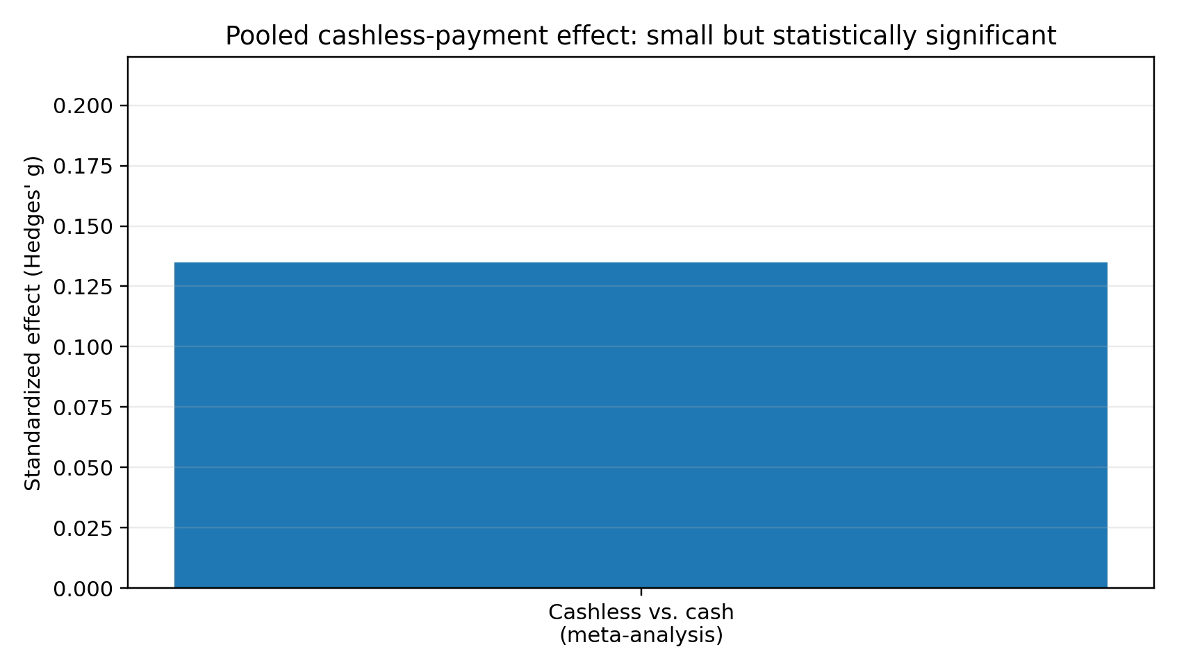
Figure 4. Pooled cashless-payment effect. Hedges’ g = 0.135 represents a small standardised difference; it is not a percentage increase in spending. The India-specific 2.38% estimate is not plotted here because it uses a different scale and estimand.

Country-wise and Year-wise Comparison
Table 1 reports the share of adults aged 15+ with an account at a financial institution or mobile-money provider. The series uses the Global Findex survey waves of 2011, 2014, 2017, and 2021. Values are rounded to one decimal place. These are indicators of financial access, not direct indicators of impulse buying or self-control.
Country / comparator | 2011 (%) | 2014 (%) | 2017 (%) | 2021 (%) | Change 2011–21 (pp)
World | 50.6 | 61.7 | 69.3 | 73.8 | +23.2
India | 35.2 | 53.1 | 79.9 | 77.5 | +42.3
Germany | 98.1 | 98.8 | 99.1 | 100.0 | +1.9
Kenya | 42.3 | 74.7 | 81.6 | 79.2 | +36.9
Note. Global and country values are drawn from World Bank Global Findex sources. Small differences can arise from rounding and survey estimates. The World Bank’s 2021 country brief reports India at 78% (rounded), consistent with the 77.5% estimate in the country dataset.
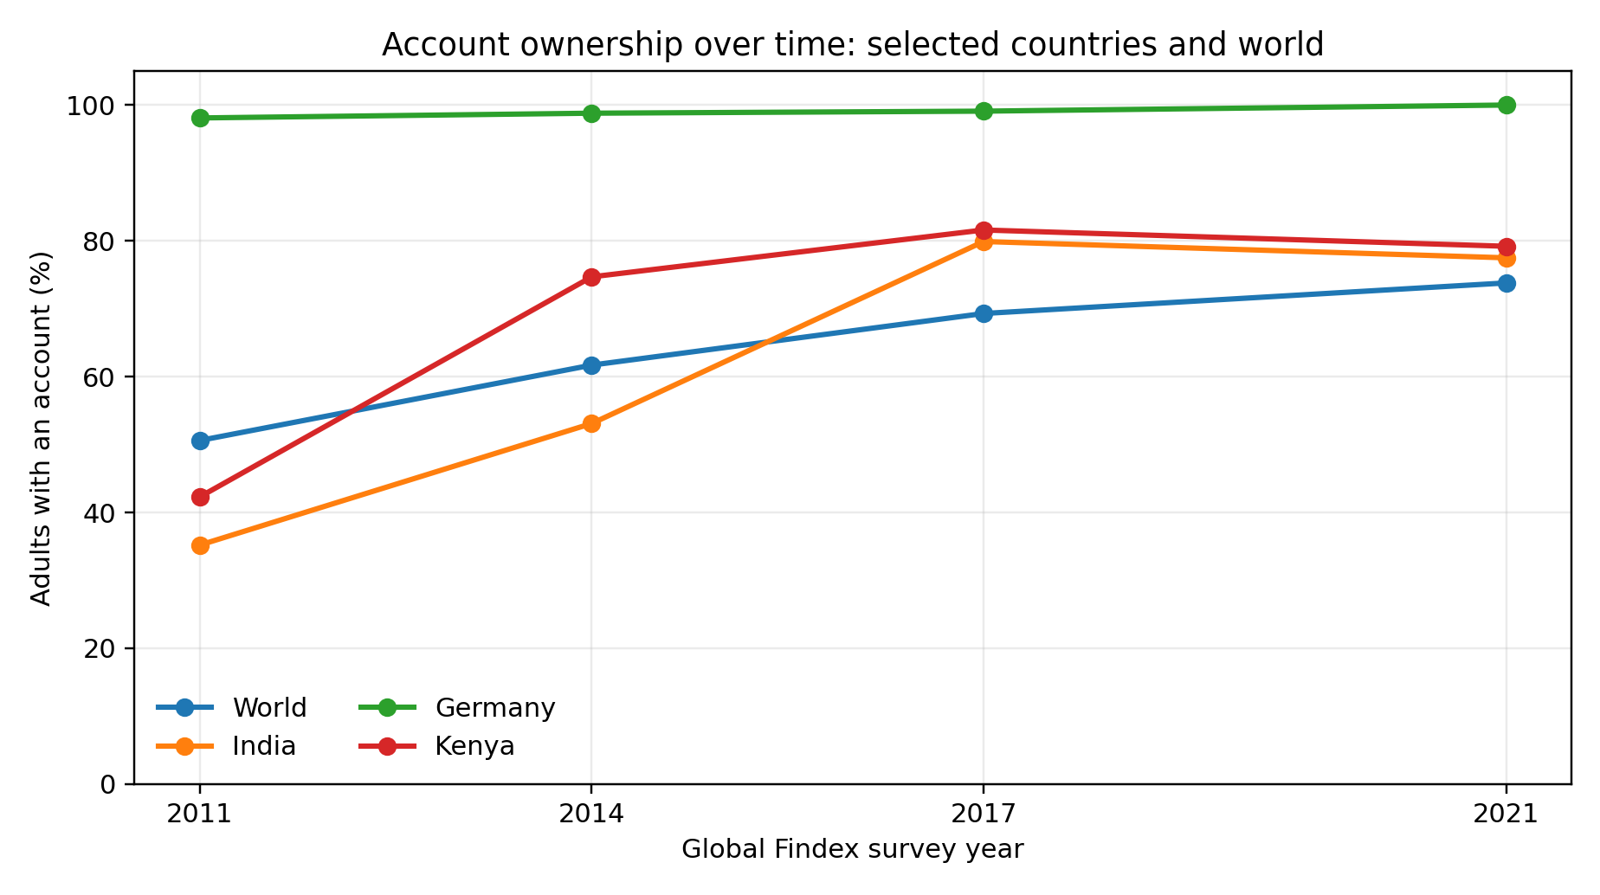
Figure 1. Account ownership trends for India, Germany, Kenya, and the world. Source: World Bank Global Findex Database, 2011–2021.
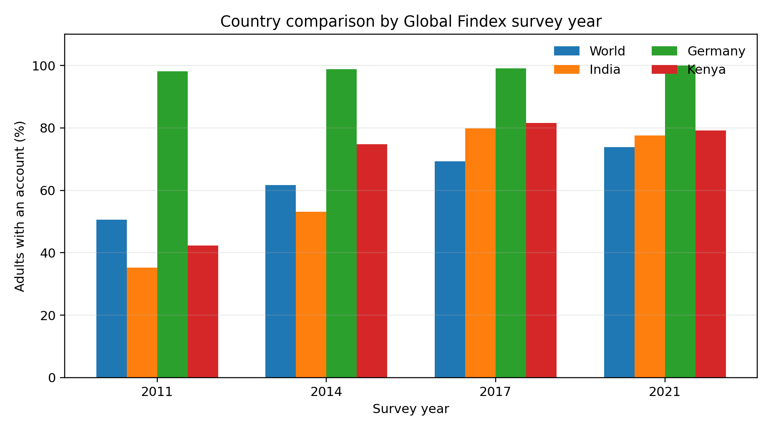
Figure 2. Country comparison by survey wave. High account ownership indicates access to formal financial services, not necessarily active use or spending control.

Regional year-wise comparison
Regional aggregates show that financial inclusion grew in all selected regions between 2011 and 2021, although the level and pace of growth differed. Asterisks indicate regional aggregates excluding high-income economies, following the cited World Bank reporting.
Region | 2011 (%) | 2014 (%) | 2017 (%) | 2021 (%) | Change 2011–21 (pp)
East Asia & Pacific* | 55.0 | 68.8 | 70.4 | 79.7 | +24.7
Europe & Central Asia* | 44.4 | 57.4 | 65.5 | 77.6 | +33.2
South Asia | 35.2 | 51.0 | 76.2 | 74.8 | +39.6
Sub-Saharan Africa* | 23.3 | 34.2 | 42.5 | 49.3 | +26.0
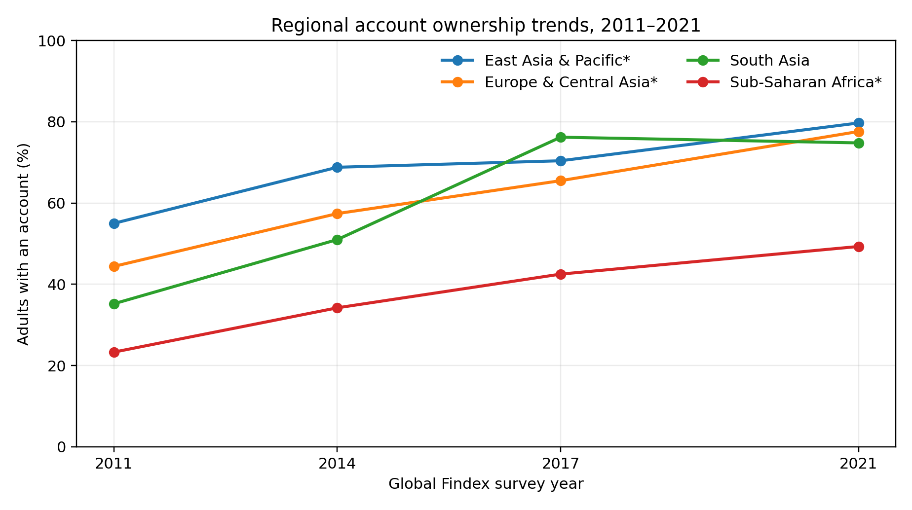
Figure 3. Regional account ownership trends, 2011–2021. Source: Global Findex regional series as reported in World Bank data summaries; * denotes selected regional aggregates excluding high-income economies.

What the comparisons do—and do not—show
The data show a broad expansion in formal financial access. India and Kenya experienced particularly large increases over the decade, while Germany began near saturation. The data do not show that people in India or Kenya became less self-controlled, nor that people in Germany have stronger self-control. To test such claims, a study would need direct measures of self-control and spending outcomes, comparable sampling, and a design that separates payment adoption from income, age, financial literacy, urbanisation, and other confounders.
Indicator | What it measures | What it cannot establish
Account ownership | Access to a financial account | Impulse buying, overspending, or self-control
Digital-payment use | Use of electronic payment methods | Whether purchases were necessary or financially harmful
Impulse-buying scale | Self-reported tendency or episode of spontaneous buying | Actual financial loss without spending/financial data
Transaction records | Observed timing, frequency, and value of spending | Motivation or self-control without additional measures
Self-control scale | Self-reported or measured regulation capacity | Causal impact on spending unless design supports it

Country-wise Financial Inclusion: Interpreting the Longitudinal Data
The Global Findex series provides a useful longitudinal context for the transformation of financial access. Account ownership among adults rose globally from approximately 50.6% in 2011 to 73.8% in the series used in this paper. India’s account ownership increased substantially over the decade, while Kenya also recorded a large rise. Germany was close to universal ownership at the start of the series and therefore had less room for further growth. These differences illustrate distinct starting points and pathways, rather than a ranking of consumer self-control.

India
India’s reported account ownership rose from 35.2% in 2011 to 53.1% in 2014 and 79.9% in 2017, before the comparable estimate in the paper reaches 77.5% in 2021. The rapid increase through 2017 is consistent with major efforts to expand account access. It is important to distinguish having an account from actively using it, having regular income, using digital payments frequently, or maintaining control over discretionary spending. Financial inclusion can support resilience and access to services, while responsible use depends on a wider set of conditions.
For the Indian context, future research should examine differences between urban and rural consumers, income groups, age cohorts, smartphone access, digital literacy, household responsibilities, and payment methods. It should also separate UPI transactions for transfers or essential purchases from transactions that are discretionary. A high volume of digital transactions does not automatically imply high discretionary consumption.

Germany and high account ownership
Germany’s near-saturation account ownership illustrates why account access alone cannot be used to infer spending restraint. When almost all adults have accounts, the indicator provides little information about differences in self-control, financial stress, or purchase behaviour. A country may have high account access while still containing households with debt burdens or limited disposable income. The relevant outcomes are therefore spending relative to resources, financial resilience, and the quality of consumer decision-making.

Kenya and mobile-money infrastructure
Kenya’s growth in account ownership reflects a context in which mobile money has played a prominent role in financial access. Mobile-based services can reduce geographic and transaction barriers, facilitate transfers, and support participation in formal financial systems. The same broad category of technology can be used for essential household transfers, business payments, savings, or discretionary purchases. Research needs to identify transaction purpose and financial outcomes before making claims about spending control.

Regional variation
Regional trends demonstrate that growth in access has not been uniform. Starting levels, infrastructure, regulation, income, financial-service availability, and the role of mobile money differ. The comparison should be read as a descriptive summary of access, with the caveat that regional definitions and the treatment of high-income economies must follow the World Bank’s source tables. It is not appropriate to treat regions as psychologically homogeneous or infer national personality characteristics from account-ownership statistics.
Comparison dimension | Question for future research | Why it matters
Income and affordability | Does unplanned spending predict financial strain after controlling for income and essential costs? | Separates behaviour from lack of resources
Payment method | Does the same person spend differently across cash, card, UPI, and credit? | Reduces bias from comparing different kinds of consumers
Transaction purpose | Are payments for essentials, transfers, business, or discretionary purchases? | Avoids treating all digital transactions as consumption
Digital literacy | Do users understand fees, notifications, and transaction histories? | Access does not guarantee effective use
Age and life stage | Do effects vary by students, working adults, and older consumers? | Needs, income, and digital familiarity differ
Consumer safeguards | Do alerts, spending dashboards, and cooling-off periods change outcomes? | Identifies actionable policy and design interventions

Year-wise Comparison: What Can Be Inferred from 2011, 2014, 2017, and 2021?
The survey waves are snapshots, not continuous annual observations. The year labels in the graphs represent survey years; they should not be interpreted as annual time-series data. A line connecting survey waves is a visual aid that summarises change between observation points. It does not establish that growth occurred at a constant rate in every intervening year.
The increase in account ownership between 2011 and 2014 indicates that a larger share of adults had formal financial access by the second wave. The further rise by 2017 indicates continued expansion. The 2021 values reflect another point in time, following a period that included the COVID-19 pandemic and further digitalisation. However, a before-and-after comparison cannot isolate the effect of the pandemic or any single policy without an appropriate design.
For spending behaviour, the evidence base is not equivalent to the Global Findex time series. The meta-analyses combine studies conducted in different years and settings; their effect sizes summarise relationships across included studies rather than annual changes in the general population. It would be misleading to construct a graph claiming that impulse buying rose from 2011 to 2021 unless comparable annual measures were available. For that reason, the present paper graphs account ownership and reports direct spending findings separately.
A rigorous annual comparison would require harmonised survey instruments administered repeatedly, transaction-level data from comparable populations, consistent definitions of discretionary and unplanned spending, and measures of self-control. Researchers would also need to account for inflation, changes in household income, pandemic-related disruptions, payment-system adoption, and shifts in online shopping. Without these controls, an apparent trend may reflect measurement changes rather than behavioural change.

Pre-AI, Platform-Commerce, and AI-Enabled Context
Period (broad) | Dominant consumer environment | Potential spending mechanism | Evidence status
2002–2009: early online commerce | Web retail, cards, email promotions, early e-commerce | Reduced search costs and convenience may alter purchase opportunities | General digital-commerce context; not a clean causal period comparison
2010–2016: mobile and social commerce | Smartphones, social platforms, app-based retail, digital wallets | Persistent access, social cues, and lower checkout friction | Mechanisms are plausible; effects depend on individual and context
2017–2022: platform and cashless expansion | Instant payments, one-click checkout, targeted ads, marketplace recommendations | Reduced payment salience and personalised prompts | Cashless effect supported by meta-analysis; country-specific causal evidence exists for India
2023 onward: generative-AI adoption | Generative AI layered onto existing recommendation, content, and advertising systems | Potentially more adaptive persuasion and synthetic content; possible benefits from budgeting assistants too | Insufficient evidence for a general causal estimate of AI-induced spending increase
This periodisation is conceptual rather than a formal interrupted time-series analysis. It must not be read as evidence that AI caused an increase in spending after 2023. Stronger inference would require transaction-level outcomes, measured AI exposure, comparison groups, and controls for changes in prices, income, platform use, and the post-pandemic consumption environment.

The Pre-AI to AI-Era Transition: A Cautious Evidence Map
The term ‘AI era’ can be used too broadly. E-commerce platforms used recommendation algorithms, predictive advertising, automated ranking, and user profiling well before the public spread of generative AI tools. A sound review distinguishes algorithmic personalisation from generative-AI content systems. Both can influence the consumer environment, but they are not the same exposure and should not be combined into a single causal variable.
In early online commerce, a consumer typically searched for products, compared options, and completed a purchase through a website. Search and checkout became easier over time, while smartphones increased the frequency with which shopping cues could reach consumers. Social commerce integrated peer signals and influencer content into shopping journeys. Later, recommendation systems became increasingly adaptive, selecting products or promotions using observed behaviour. Generative AI adds the possibility of conversational product discovery, personalised explanations, synthetic promotional content, and interactive sales assistance. These changes may affect attention, trust, information search, and perceived urgency, but the direction and magnitude of any spending effect require direct testing.
AI may also support financial self-control. A well-designed assistant could categorise transactions, explain spending patterns, identify subscriptions, compare prices, or remind a user of a self-defined budget. Potential risks include persuasive over-personalisation, inaccurate advice, privacy concerns, fabricated product claims, and interfaces that encourage dependence. The appropriate research question is therefore not simply whether AI is good or bad, but what system design, user characteristics, and safeguards produce beneficial or harmful outcomes.
Technology period | Typical features | Possible pathway to spending | Research requirement
Early e-commerce | Web catalogues, email offers, online checkout | Convenience and broader product availability | Compare online and offline purchase records
Mobile/social commerce | Smartphone access, influencers, social proof, mobile wallets | Frequent cue exposure and social comparison | Measure exposure, emotional response, and purchase timing
Algorithmic personalisation | Recommendations, retargeting, behavioural ad targeting | More relevant or more persistent prompts | Audit recommendation exposure and use controlled comparisons
Generative AI interfaces | Conversational shopping, generated content, AI assistants | Trust, persuasion, information simplification, or budgeting support | Separate AI exposure from existing algorithms and measure actual transactions

Discussion
Three conclusions emerge. First, self-control matters, but consumer spending is multi-determined. A psychologically plausible model should include personal characteristics, emotions, affordability, social influence, marketing stimuli, and payment design. Second, cashless payments can modestly increase spending on average, but the size of the effect is heterogeneous and has weakened over time in the meta-analytic evidence. Third, the cross-country expansion of account ownership describes a major change in access to finance; it does not provide direct evidence about self-control or overspending.
The India study is especially relevant because it goes beyond simple correlation: the 2016 demonetisation created a setting for identifying spending changes associated with a forced shift toward digital payments. Its findings support the possibility that payment method affects the experience of paying. Nevertheless, the effect size should not be presented as the average impact of UPI or digital payments in contemporary India, because the policy shock, baseline cash dependence, period, and payment infrastructure differ from current circumstances.
The AI-era discussion calls for restraint in claims. Personalised recommendation and algorithmic marketing may increase cue exposure and reduce the time available for reflection, but an overall causal effect of generative AI on spending is not established by the sources reviewed. Research should examine both risks and benefits: AI tools may also help consumers track expenditure, compare prices, set budgets, or identify subscriptions.

Synthesis of Evidence Strength
Claim | Evidence strength in this review | Appropriate wording
Impulse buying has multiple antecedents | Strong synthesis from meta-analysis | Evidence indicates a multi-factor process involving traits, motives, resources, emotions, and marketing stimuli.
Financial self-control strategies can improve spending/saving outcomes | Meta-analysis across 29 studies | Reviewed strategies produced a medium average effect, with usual caveats about study quality and publication bias.
Cashless payments are associated with somewhat higher spending | Meta-analysis, small pooled effect | The average cashless effect is small and heterogeneous; it varies by context.
Digital payment shifts increased spending in the India demonetisation setting | Setting-specific quasi-experimental evidence | The study reports an increase under a distinctive policy shock; generalisation should be cautious.
Account ownership increased across selected countries/regions | Official descriptive secondary data | Financial access expanded; this does not measure self-control or impulse buying.
Generative AI has increased consumer spending globally | Not established by the sources reviewed | A causal effect is not established; direct exposure and transaction data are needed.
This evidence-strength summary is central to the paper’s academic credibility. It distinguishes findings that are supported by meta-analysis or quasi-experimental evidence from contextual observations and research questions. A longer paper should not be made to appear more certain than the evidence allows.

Final Integrative Model
The reviewed evidence can be integrated into a conceptual model in which spending behaviour is produced by the interaction of five domains: (1) individual factors, including trait self-control, financial literacy, and preferences; (2) affective and cognitive states, including mood, urgency, attention, and perceived value; (3) transaction design, including payment salience, checkout friction, credit terms, and feedback; (4) social and marketing context, including norms, promotions, recommendations, and algorithmic personalisation; and (5) structural resources, including income, essential expenses, access to financial services, and financial shocks. The resulting behaviour may be planned or unplanned and may have positive, neutral, or negative consequences.
The model suggests that interventions can operate at more than one level. Individual-level strategies can strengthen goals and monitoring. Interface-level strategies can make costs visible and introduce a pause. Institutional strategies can improve financial education and consumer protection. Structural measures can address barriers to financial security. This multi-level approach avoids explaining financial outcomes solely through personal character and offers a more realistic framework for research and practice.

Ethical Considerations and Consumer Protection
Research on personal spending often involves sensitive information. Bank transactions can reveal health-related purchases, religious or political donations, travel, relationships, and other private activities. Researchers should collect only the data necessary to answer the question, obtain informed consent, anonymise records, restrict access, and specify retention and deletion procedures. Where transaction records are used, participants should be able to understand which data are collected and how they will be analysed.
AI-enabled personalisation introduces additional ethical questions. A system may infer vulnerability from behaviour or target consumers when they are emotionally distressed. Consumers may not understand why a product is being recommended or how their data are used. Transparent advertising labels, clear explanations of recommendation logic where feasible, accessible opt-outs, and limits on manipulative urgency cues can help protect autonomy. Ethical evaluation should also consider unequal effects: users with lower digital literacy or limited financial resources may be less able to identify misleading claims or manage repeated prompts.
Consumer protection should not shift all responsibility onto individuals. A budget tool can help, but it cannot compensate fully for deceptive fees, unaffordable credit, misleading discounts, or aggressive interface design. The most defensible approach combines personal strategies with responsible institutional design, financial education, and proportionate regulation.

Measurement and Research Design Recommendations
A stronger empirical follow-up should define its outcome before selecting its predictor. ‘Spending behaviour’ may mean total expenditure, discretionary expenditure, purchase frequency, unplanned purchase frequency, spending relative to income, credit use, saving rate, or post-purchase regret. These outcomes are related but not interchangeable. A study that measures only self-reported impulse-buying tendency should not claim to have measured actual overspending.

Recommended constructs
Construct | Possible operational measure | Potential limitation
Trait self-control | Validated self-report scale | Self-report and social desirability bias
Impulse buying | Validated impulse-buying tendency scale and episode diary | Tendency is not identical to actual transaction behaviour
Actual spending | Participant-authorised transaction records or structured spending logs | Privacy, incomplete coverage, and coding error
Financial well-being | Validated subjective financial well-being scale plus objective indicators | Subjective and objective indicators may diverge
Digital-payment exposure | Frequency and value by method, not account ownership alone | Payment method may be selected by the consumer
AI/algorithmic exposure | Logged exposure to recommendations or experimentally assigned content | Exposure may be difficult to isolate on live platforms
Emotional state | Brief repeated mood measure near purchase episodes | Measurement itself may alter behaviour
Financial literacy | Knowledge questions on interest, inflation, credit, and risk | Knowledge does not guarantee action

Proposed hypotheses for future empirical work
The following are proposed hypotheses for future testing, not findings established by the present review:
- H1: Higher trait self-control will be associated with fewer unplanned discretionary purchases after controlling for income, age, and financial literacy.
- H2: Lower payment salience will be associated with higher unplanned spending, with the relationship moderated by self-monitoring and transaction feedback.
- H3: Financial self-control strategies will predict better adherence to self-defined spending limits.
- H4: Emotional arousal and time pressure will partially explain the association between promotional cues and impulse-buying episodes.
- H5: The relationship between digital-payment use and spending will vary by transaction purpose, income, and consumer familiarity with the payment method.
- H6: AI-personalised recommendations will have different effects depending on transparency, perceived urgency, and whether the system is designed to sell or support budgeting.

Recommended analysis
A cross-sectional survey could estimate associations but would not establish temporal order. Longitudinal data would allow researchers to examine within-person change, although time-varying confounding would remain. Randomised experiments could test the effect of checkout friction, spending alerts, or recommendation framing under controlled conditions. Natural experiments may be useful when payment infrastructure or platform rules change, but identification assumptions should be stated clearly. For repeated transaction outcomes, multilevel models can account for observations nested within people and people nested within regions. Results should report effect sizes and confidence intervals, not only statistical significance.
Country comparisons require measurement equivalence. Translated scales should be tested for reliability and comparable factor structure. Sampling should account for differences in urbanisation, income, internet access, education, and age. Country-level differences should not be attributed to culture unless culture is measured directly and alternative explanations are considered. The strongest cross-country design would combine harmonised individual-level measures with country-level indicators and pre-specified hypotheses.

Expanded Practical Framework: From Awareness to Behaviour Change
A practical intervention can be organised into five stages: awareness, planning, friction, monitoring, and review. Awareness involves identifying the spending categories and contexts in which unplanned purchases occur. Planning translates a broad goal such as ‘save more’ into a specific target and schedule. Friction introduces a pause between urge and purchase. Monitoring makes spending visible through a weekly summary. Review compares the outcome with the goal and adjusts the plan without treating every deviation as personal failure.
Stage | Example action | Mechanism | Evaluation indicator
Awareness | Keep a two-week spending and mood diary | Identifies cues and recurring patterns | Share of transactions with purpose and context recorded
Planning | Set category limits and automatic savings | Makes the long-term goal concrete | Budget adherence and amount saved
Friction | Use a waiting period for non-essential purchases | Creates time for reflection | Proportion of delayed purchases later cancelled
Monitoring | Review transaction records weekly | Improves feedback and cost visibility | Difference between planned and actual spending
Review | Reassess goals monthly and adjust limits | Supports learning rather than all-or-nothing thinking | Repeated overspend episodes and goal progress
These strategies should be adapted to the person’s circumstances. Cash budgeting may help some people, but cashless methods may be necessary or safer for others. Automatic savings should be set at a realistic amount to avoid overdrafts or missed essential payments. A waiting period is most appropriate for discretionary purchases, not urgent necessities. The aim is to make informed, affordable choices easier—not to prohibit enjoyment or assume that every purchase requires scrutiny.

Implications for Universities and Young Adults
University students are a relevant population because many are learning to manage money independently while balancing education expenses, transport, food, housing, social participation, and sometimes part-time employment. Income may be irregular, and spending decisions may be influenced by peer groups, online trends, entertainment platforms, food delivery, subscription services, and promotional offers. These factors do not make students inherently less responsible; they create a context in which financial skills and accessible supports can be valuable.
Universities can integrate financial well-being into student support through short workshops on budgeting, digital payment safety, credit costs, subscriptions, online shopping cues, and emergency savings. Activities can use realistic scenarios rather than only lectures. Students can compare the total cost of an instalment purchase with an upfront purchase, build a monthly budget, or identify the difference between an essential and a discretionary expense. The goal is not to shame spending but to increase informed choice and confidence.
Counselling and student-support services may also help students who report persistent distress related to debt, compulsive shopping, family financial pressure, or conflict around money. Staff should distinguish financial education needs from mental-health concerns and refer students appropriately. Financial difficulty should not be presumed to result from poor self-control; structural and family circumstances must be considered.
For research, student samples are convenient but may not represent the wider population. Findings from university students should be labelled accordingly and should not be generalised to all adults or countries. Future studies could compare students with working adults using the same measures while accounting for age, income, financial independence, and access to credit.

Practical Implications and Recommendations

For consumers
- Use a written or app-based monthly budget and set category-specific limits before shopping.
- Apply a 24-hour waiting rule to non-essential purchases above a personally chosen threshold.
- Disable non-essential shopping notifications and promotional emails; remove saved payment details where impulsive purchases are a concern.
- Review digital transactions weekly and compare actual spending with the budget rather than relying on memory.
- Use automatic saving or separate accounts to protect essential expenses and longer-term goals.
- When using AI budgeting tools, verify transaction categorisation, protect personal data, and retain human oversight of financial decisions.

For educators and institutions
Financial education should combine concepts with behavioural practice: budgeting exercises, opportunity-cost calculations, delayed-purchase routines, credit and interest simulations, and reflection on emotional triggers. Institutions should avoid framing financial difficulty solely as an individual self-control failure because low income, unstable employment, debt costs, and limited access to affordable services can constrain choices.

For platforms and policymakers
Digital platforms can support informed decisions through clear total-cost displays, spending summaries, easy cancellation, transparent advertising labels, and friction for high-risk or repeated purchases. Policymakers and researchers should evaluate these measures empirically and consider privacy, accessibility, and unintended effects. AI-driven systems should be assessed for transparency, manipulation risks, and the possibility of improving consumer financial capability.

Evidence-Based Recommendations from the 20-Year Review
1. Build financial self-control around supportive systems, not willpower alone. The meta-analysis of 29 studies found that financial self-control strategies reduced spending and increased saving with a medium average effect (Davydenko et al., 2021). Consumers and educators should prioritise realistic budgets, automatic saving, spending limits, separate savings pots, and cooling-off periods for non-essential purchases. Evaluate these supports using budget adherence and saving outcomes, not intentions alone.
2. Make digital spending visible and reviewable. The cashless-payment meta-analysis found a small average effect that varied across studies (Schomburgk et al., 2024). Payment providers should offer clear transaction histories, category summaries, user-controlled alerts, and optional confirmation for large discretionary purchases. Consumers can compare planned and actual spending at least weekly.
3. Reduce manipulative urgency in online shopping. Platforms should clearly disclose total prices, recurring charges, credit costs, and genuine offer conditions. Countdown timers, scarcity claims, personalised prompts, and one-click checkout should not obstruct informed choice. This is a consumer-protection recommendation based on known cue and friction mechanisms, not a claim that generative AI has been proven to increase spending.
4. Match financial interventions to consumers’ circumstances. Overspending should not automatically be attributed to weak self-control. Income adequacy, essential costs, debt, financial shocks, digital literacy, and access to safe payment services also matter. Behavioural tools should be paired with accessible financial guidance and debt support where appropriate.
5. Embed digital financial well-being in university support. Universities should offer practical sessions on budgeting, subscriptions, UPI/card safety, buy-now-pay-later terms, online shopping cues, and transaction-history review. Support should be non-stigmatising and refer students experiencing persistent debt-related or buying-related distress to appropriate services.
6. Use stronger evidence to connect access, payments, and spending. Global Findex account-ownership data describe financial access, not self-control or impulse purchases. Future research should combine validated scales with consent-based transaction records, distinguish essential from discretionary expenditure, and test differences by age, income, country, and payment method.
7. Treat AI-era effects as an open research question. Researchers should separate generative-AI interfaces from established recommender systems, retargeting, and personalised advertising. Studies should measure exposure and actual transactions, use longitudinal or experimental designs where ethical, and compare AI budgeting support with AI-enabled sales prompts. Until robust evidence emerges, claims should be framed as potential mechanisms rather than established causal effects.

Limitations and Future Research
This paper is a narrative evidence review, not a registered systematic review. The selected studies differ in design, population, measurement, and context; their findings cannot be pooled here into a new common effect estimate. The country comparison is restricted to account ownership and four Global Findex waves, because those are comparable indicators reported in the cited sources. Account ownership does not measure transaction intensity, impulse buying, financial distress, or self-control.
Future research should: (a) use longitudinal transaction data alongside validated self-control and impulse-buying measures; (b) compare countries with harmonised sampling and measures; (c) distinguish cash, card, UPI/mobile wallet, credit, and buy-now-pay-later transactions; (d) measure exposure to recommendation systems and generative-AI content directly; (e) preregister hypotheses and report effect sizes with confidence intervals; and (f) test behavioural interventions such as cooling-off prompts, budget alerts, and spending dashboards. For an empirical paper, the authors should also document a reproducible search strategy, inclusion/exclusion criteria, risk-of-bias assessment, and screening flow diagram.

Conclusion
The evidence reviewed suggests that self-control is an important but not exclusive contributor to spending behaviour. Impulse buying reflects a combination of individual dispositions, affective states, situational cues, and marketing conditions. Cashless payments are associated with a small average increase in spending in meta-analytic evidence, while India-specific quasi-experimental findings indicate that a forced shift from cash toward digital payments can raise spending in a particular policy context. Global Findex data show major growth in financial account access across countries and regions, but those trends should not be mistaken for evidence of changes in self-control. Finally, AI-enabled marketing raises important questions about cue exposure and consumer autonomy, yet a general causal claim that generative AI increases spending is premature. The strongest practical approach is to combine individual financial self-control strategies with transparent, consumer-supportive payment and platform design.

References
Agarwal, S., Ghosh, P., Li, J., & Ruan, T. (2024). Digital payments and consumption: Evidence from the 2016 demonetization in India. The Review of Financial Studies, 37(8), 2550–2585. https://doi.org/10.1093/rfs/hhae005
Baumeister, R. F. (2002). Yielding to temptation: Self-control failure, impulsive purchasing, and consumer behavior. Journal of Consumer Research, 28(4), 670–676. https://doi.org/10.1086/338209
Iyer, G. R., Blut, M., Xiao, S. H., & Grewal, D. (2020). Impulse buying: A meta-analytic review. Journal of the Academy of Marketing Science, 48, 384–404. https://doi.org/10.1007/s11747-019-00670-w
Davydenko, M., Kolbuszewska, M., & Peetz, J. (2021). A meta-analysis of financial self-control strategies: Comparing empirical findings with online media and lay person perspectives on what helps individuals curb spending and start saving. PLOS ONE, 16(7), e0253938. https://doi.org/10.1371/journal.pone.0253938
Pick, D., & Eisend, M. (2014). Buyers’ impulse purchases: A meta-analytic review. Journal of Retailing and Consumer Services, 21(2), 86–97. https://doi.org/10.1016/j.jretconser.2013.11.004
Schomburgk, L., Belli, A., & Hoffmann, A. O. I. (2024). Less cash, more splash? A meta-analysis on the cashless effect. Journal of Retailing, 100(3), 382–403. https://doi.org/10.1016/j.jretai.2024.05.003
Strömbäck, C., Lind, T., Skagerlund, K., Västfjäll, D., & Tinghög, G. (2017). Does self-control predict financial behavior and financial well-being? Journal of Behavioral and Experimental Finance, 14, 30–38. https://doi.org/10.1016/j.jbef.2017.04.002
Tangney, J. P., Baumeister, R. F., & Boone, A. L. (2004). High self-control predicts good adjustment, less pathology, better grades, and interpersonal success. Journal of Personality, 72(2), 271–324. https://doi.org/10.1111/j.0022-3506.2004.00263.x
World Bank. (2018). The Global Findex Database 2017: Measuring financial inclusion and the fintech revolution. World Bank. https://doi.org/10.1596/978-1-4648-1259-0
World Bank. (2022). The Global Findex Database 2021: Financial inclusion, digital payments, and resilience in the age of COVID-19. World Bank. https://doi.org/10.1596/978-1-4648-1897-4
World Bank. (2022, June 29). COVID-19 drives global surge in use of digital payments. https://www.worldbank.org/en/news/press-release/2022/06/29/covid-19-drives-global-surge-in-use-of-digital-payments
Zhao, Y., Li, Y., Wang, N., Zhou, R., & Luo, X. (2022). A meta-analysis of online impulsive buying and the moderating effect of economic development level. *Information Systems Frontiers, 24*(5), 1667–1688. https://doi.org/10.1007/s10796-021-10170-4

