Image-Based Breed Recognition of Cattle and Buffaloes of India: A Deep Learning Framework and Literature Survey

First A. Author¹, Second B. Author², and Third C. Author³[Font: Times New Roman, Size:11]
¹Member, Institute/Organization name[Font: Times New Roman, Size:11]
²Member, Institute/Organization name[Font: Times New Roman, Size:11]
³Member, Institute/Organization name[Font: Times New Roman, Size:11]

Abstract—India holds the world's largest bovine population and one of the richest pools of indigenous cattle and buffalo genetic diversity, with 55 cattle breeds and 22 buffalo breeds officially registered by the ICAR National Bureau of Animal Genetic Resources (NBAGR). Accurate breed identification underpins breeding-value assessment, milk-yield prediction, insurance underwriting, conservation planning under schemes such as the Rashtriya Gokul Mission, and the government's Bharat Pashudhan / Pashu Aadhaar digital livestock infrastructure. In practice, breed identification is still performed manually by field-level workers and veterinarians using visual cues such as coat colour, hump shape, horn orientation, and ear morphology — a process that is subjective, slow, and inconsistent across observers, and that scales poorly against a tagged bovine population exceeding 280 million animals. This paper surveys the emerging body of work on image-based, deep-learning-driven breed recognition for Indian cattle and buffaloes, situates it within the broader literature on fine-grained animal breed classification, and proposes a consolidated end-to-end framework — spanning data curation, animal detection, transfer-learning-based classification, explainability, and field deployment through mobile and government-platform integration. We summarize reported results from existing Indian-specific studies, which range from roughly 70% to above 90% accuracy depending on breed count, dataset size, and architecture, and we discuss the specific technical obstacles this domain presents: high inter-breed visual similarity, wide intra-breed variation, uncontrolled field-capture conditions, severe class imbalance for rare and endangered breeds, and the need for lightweight, low-connectivity-tolerant inference suitable for rural deployment. We conclude with concrete directions for dataset standardization, model benchmarking, and integration with India's national livestock data infrastructure.
Index Terms—Cattle breed recognition, buffalo breed classification, convolutional neural networks, transfer learning, fine-grained image classification, Indian indigenous breeds, Bharat Pashudhan, Pashu Aadhaar, precision livestock farming, computer vision
I. INTRODUCTION
Cattle and buffaloes are central to India's rural economy. The 20th Livestock Census (2019) recorded a national cattle population of approximately 193.46 million and a buffalo population of approximately 109.85 million, together making up the majority of India's roughly 303.76 million-strong bovine population [1]. An estimated 142.11 million of those cattle, 73.45% of the total, are classified as indigenous or nondescript, meaning they belong to, or descend from, one of India's native breeds rather than an exotic or crossbred lineage [1]. These indigenous breeds are the product of centuries of natural and community-led selection for traits suited to local climate, forage availability, and draught or dairy use. They remain the genetic foundation that most of the country's milk, draught power, and rural livelihoods still depend on.
Breed identification is the entry point for nearly every downstream livestock intervention. It determines which artificial insemination protocol and semen source is appropriate, informs milk-yield and breeding-value expectations, sets insurance premiums and payouts, and serves as the basic unit of accounting for conservation programmes such as the Rashtriya Gokul Mission (RGM), which is specifically mandated to conserve and genetically upgrade indigenous bovine breeds recognized by NBAGR [2], [3]. It is also the foundation of India's growing digital livestock infrastructure. The Bharat Pashudhan platform and its associated Pashu Aadhaar scheme assign a unique 12-digit identification number to individual animals, linked to health, breeding, and ownership records through the Information Network for Animal Productivity and Health (INAPH) database. As of recent reporting, roughly 286.5 million of an estimated 303 million bovines, about 95%, have been tagged under this system [4], [5], and breed is one of the core fields recorded at the point of animal registration [6].
Despite this digital infrastructure, breed determination itself remains a manual, visual task performed by field-level workers (FLWs) and veterinarians, most of whom rely on trained visual judgment of coat colour and pattern, hump size and position, horn shape and orientation, dewlap and ear morphology, and body conformation. This approach has three persistent weaknesses. First, it is subjective: two observers examining the same animal, particularly a crossbred or a young animal whose breed-defining features have not fully developed, can reasonably disagree. Second, it does not scale. India adds tens of millions of new livestock records to its national database every year, and manual breed assessment at that volume is a genuine operational bottleneck for FLWs already responsible for vaccination, insemination, and health reporting duties [4]. Third, it is difficult to audit, since a paper or app-based breed entry, once recorded, is rarely independently re-verified. That allows misclassification to persist silently in downstream records used for breeding and subsidy decisions.
Advances in convolutional neural networks (CNNs) and, more recently, vision transformers have made image-based fine-grained animal classification a practically viable alternative to purely manual assessment. Published work now spans dog breeds, horse breeds, camel breeds, and wildlife species identification [7]–[12]. A smaller but rapidly growing body of work has begun applying the same techniques specifically to Indian cattle and buffalo breeds, motivated directly by the scale and stakes of the identification problem described above [13]–[16]. This paper contributes to that body of work in three ways. First, Section II and Section III review the existing literature and the structure of India's registered breed diversity, giving a reader unfamiliar with the domain the context needed to evaluate technical design choices. Second, Section IV and Section V analyze the specific challenges this classification problem poses and propose a consolidated, end-to-end system architecture that integrates detection, classification, explainability, and field deployment, informed by design choices reported across the surveyed literature. Third, Section VI collects and compares the accuracy figures reported by existing Indian-specific studies, and Section VII discusses how a system of this kind could integrate with India's existing Bharat Pashudhan and Rashtriya Gokul Mission infrastructure, an integration path that, to our knowledge, prior work has discussed only briefly despite it being the most direct route to real-world impact.
II. RELATED WORK
Fine-grained visual classification, the task of distinguishing between visually similar sub-categories of a broader class, is a well-established computer vision problem, and animal breed identification is one of its most active application domains. Early work in this space relied on hand-crafted features such as Local Binary Patterns and Histograms of Oriented Gradients combined with classical classifiers, but these approaches were consistently outperformed once CNN-based transfer learning became practical. That shift is documented across dog breed classification studies using architectures from AlexNet through Xception-based feature extraction [7], [8], and fine-grained attention mechanisms such as multi-attention CNNs [9] have further improved discrimination between visually similar sub-categories. Foundational CNN architectures used throughout this literature include VGGNet [17], ResNet [18], MobileNetV2 [19], the EfficientNet and EfficientNetV2 families [20], [21], and, in detection-oriented pipelines, the YOLO family of single-stage object detectors [22]. Vision transformers, introduced by Dosovitskiy et al. [23], have more recently been adopted as classification backbones in livestock and animal breed studies where sufficient training data is available.
Beyond dogs, breed- or species-level fine-grained classification has been studied for horses, using a comparative evaluation of InceptionV3, NASNetLarge, PNASNet, MobileNetV3, and the EfficientNetV2 family, with NASNetLarge reported as the best-performing backbone at 85.80% test accuracy on the authors' proposed dataset [10]. A similar approach has been applied to Arabian camels, using a two-stage hierarchical framework that first separates Arabian from non-Arabian camels before classifying five Arabian breeds; DenseNet121 achieved 98% binary and 76% five-class accuracy there, outperforming ResNet50 and EfficientNetB0 on the same task [11]. For wildlife and wildcat identification, comparative studies have found ResNet50 and DenseNet variants consistently among the strongest performers relative to VGG-style and shallower custom CNNs [12], [24]. A separate but methodologically related body of work applies similar CNN pipelines to livestock product classification, such as EfficientNetV2S-based beef component classification from smartphone-captured images under uncontrolled lighting, achieving 0.92 precision and recall across classes [25]. That last result is a useful data point precisely because it, like Indian field breed photography, involves uncontrolled, non-laboratory image capture conditions.
Within the Indian cattle and buffalo domain specifically, published and preprint work remains limited relative to the scale of the underlying problem, but several recent studies establish useful reference points. Jaiswal et al. [13] applied deep transfer learning to Indian cattle breed classification as an early domain-specific study. More recently, a transfer-learning approach built on EfficientNetV2-S reported 90.93% validation and 90.68% test accuracy on a stratified 2,427-image dataset spanning multiple breeds, using focal loss, weighted random sampling to address class imbalance, and test-time augmentation [14]. A YOLOv12-based pipeline integrated with the Roboflow cloud platform, aimed directly at field-level-worker workflows and Bharat Pashudhan App integration, reported 69.8% mean Average Precision at an IoU threshold of 0.5 across 15 major breeds on 3,683 annotated images, with breed-specific accuracy reaching 87% for Bargur and 85% for Dangi; the authors also report a measured 40–60% reduction in field-level-worker workload during field testing [15]. A lightweight model built specifically to distinguish two visually similar white-coloured breeds, Tharparkar and Hariana, without expert assistance reported 72.5% classification accuracy, with a compact 3.27-million-parameter footprint and roughly 618 ms inference time per image, explicitly framed as a step toward mobile-deployable breed identification [16]. Outside peer-reviewed publication, open-source projects have also emerged: a YOLO-based classifier paired with a retrieval-augmented-generation chatbot for Indian bovine breed information [26], and a Vision Transformer-based web application covering 26 classes spanning 21 cattle and 5 buffalo breeds, deployed as a public inference demo [27]. Curated image datasets supporting this line of work are also available through IEEE DataPort [28] and Kaggle [29], the latter covering images and metadata for 50 officially recognized Indian cattle breeds.
Taken together, this literature establishes two consistent findings that motivate the framework proposed in this paper. First, transfer learning from ImageNet-pretrained backbones is the dominant and most data-efficient approach across every Indian-specific study identified, matching the pattern in the broader fine-grained animal classification literature; no reviewed study trains a large CNN from scratch. Second, reported accuracy varies substantially, from below 70% mean Average Precision in a 15-breed detection setting [15] to above 90% test accuracy in a more tightly curated, stratified classification setting [14]. This variation appears to track dataset curation quality, class count, and class balance at least as strongly as it tracks backbone architecture choice, which is why this paper places its emphasis on data curation and detection preprocessing in Section V rather than treating backbone selection as the primary design lever.
III. OVERVIEW OF INDIAN CATTLE AND BUFFALO BREED DIVERSITY
As of the most recent Breed Registration Committee update, ICAR-NBAGR has formally registered 55 indigenous cattle breeds and 22 indigenous buffalo breeds, out of 242 total registered indigenous livestock and poultry breeds across all species [30]. Registration is a deliberate, evidence-based process. Any citizen or institution may propose a candidate breed, which NBAGR's Breed Registration Cell screens before forming an expert committee, drawing one member from NBAGR and one from the relevant species-specific ICAR institute, to conduct on-ground verification in the breed's native tract before the Breed Registration Committee grants an accession number [30]. This means the registered breed count is a living figure: it stood at 212 in January 2023, reached 230 by early 2025, and 242 by early 2026 as new candidate breeds completed verification, including the Kathani and Sanchori cattle breeds of Maharashtra and Rajasthan and the Purnathadi buffalo breed of Maharashtra [31]–[33]. A breed recognition system intended for long-term deployment should therefore treat its breed taxonomy as a versioned, updatable artifact rather than a fixed label set, a design implication we return to in Section V.
Indian cattle breeds are broadly grouped by primary utility into milch (dairy) breeds such as Gir, Sahiwal, and Red Sindhi; dual-purpose breeds such as Tharparkar, Rathi, and Kankrej, valued for both milk and draught capability; and draught breeds such as Amritmahal, Hallikar, and Kangayam, historically selected primarily for work capacity. Buffalo breeds are similarly regionally distinct. Murrah, native to Haryana and adjoining Punjab, is by far the most numerically dominant and widely distributed dairy buffalo breed, contributing a reported 42.8% of India's buffalo population and now found well beyond its native tract because of its high milk yield [34]. Jaffarabadi and Mehsana are prominent in Gujarat, Nili-Ravi is concentrated in Punjab, Bhadawari is associated with the Agra–Etawah belt of Uttar Pradesh and adjoining Madhya Pradesh, and Banni is native to the Kutch region of Gujarat [35]. Several breeds in both species are geographically localized and numerically small, including Punganur cattle, a dwarf breed now considered vulnerable. This illustrates that breed recognition in the Indian context is not a balanced-class problem: a handful of widely distributed breeds (Gir, Sahiwal, Murrah, and a small number of others) account for a large share of the animal population and of any naturally collected image dataset, while dozens of regionally confined breeds are comparatively data-poor by default [3].
This distribution has a direct bearing on model design. A classifier trained on an unweighted, naturally collected dataset will tend to perform well on numerically dominant breeds and poorly on rare ones, which is unfortunate because those rare breeds are precisely the ones that conservation programmes such as RGM most need to track accurately: population trends for less common breeds are exactly what such programmes exist to monitor and reverse where they are declining [3]. Reported livestock census data illustrates this dynamic directly. Purebred Gir cattle numbers rose by roughly 70% between the 2012 and 2019 censuses, coinciding with concentrated RGM breeding investment, while other indigenous breeds such as Sahiwal and Hariana saw comparatively little growth or, in some cases, decline over the same period [36]. A breed recognition system that inherits this same imbalance in its training data, without explicit correction, risks reinforcing the same skew in whichever downstream process consumes its predictions, for instance by producing systematically less reliable breed tags for exactly the animals whose accurate registration matters most for conservation tracking.
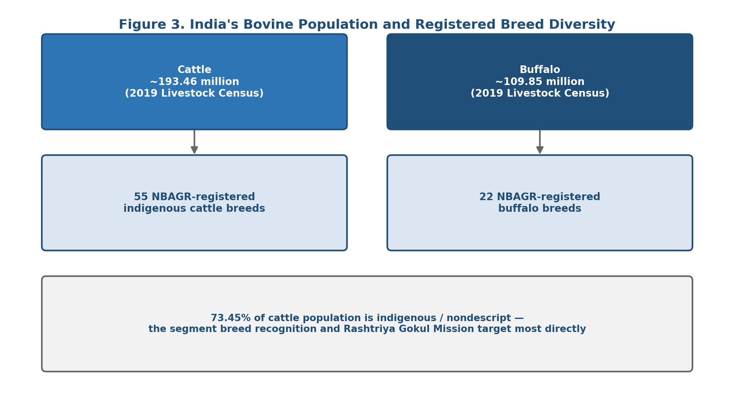
Fig. 3. India's bovine population and NBAGR-registered breed diversity.
IV. PROBLEM FORMULATION AND CHALLENGES
We formulate breed recognition as a supervised, single-label (or, where crossbred animals are explicitly modelled, multi-label) image classification problem: given an RGB image of a bovine animal captured under uncontrolled field conditions, predict its breed from a defined taxonomy of NBAGR-registered breeds plus an explicit "nondescript / crossbred" category, ideally accompanied by a calibrated confidence score. Several characteristics of this specific problem distinguish it from more thoroughly studied fine-grained classification tasks such as dog breed identification or bird species recognition, and each has direct design consequences addressed in Section V.
Inter-breed visual similarity. Several pairs of registered breeds are distinguishable primarily by subtle differences in coat shade, horn curvature, or body proportion rather than by any single dominant visual feature. The white-coloured Tharparkar and Hariana breeds are a documented example: a recent study targeting exactly this pair, using a lightweight model without additional expert-provided features, achieved only 72.5% accuracy, meaningfully below the 90%-plus range reported for less visually confusable breed sets. That gap indicates some breed pairs remain a genuinely hard sub-problem even with modern architectures [16], and it suggests that aggregate accuracy figures reported for a full breed taxonomy can understate the error rate on specific, visually similar breed pairs. Per-pair confusion analysis, not just overall accuracy, is necessary to characterize a model's real-world reliability.
Intra-breed variation and uncontrolled capture conditions. A single breed can present considerable visual variation across age, sex, individual animals, and geographic sub-population. Field photographs, taken by FLWs on mobile phones during routine visits rather than in a studio, also vary widely in camera angle, distance, lighting, occlusion by other animals or handlers, and background clutter. The YOLOv12-based field pipeline discussed in Section II reports a comparatively modest 69.8% mAP@0.5 across 15 breeds in this uncontrolled field-deployment setting, noticeably below the accuracy reported by studies working from more curated image collections [15], [14]. That gap underscores that capture-condition variability, not just breed count, is a major driver of real-world accuracy.
Severe and structural class imbalance. As discussed in Section III, a small number of breeds dominate the actual population and therefore any naturally collected dataset, while dozens of registered breeds are numerically rare by nature rather than by an accident of data collection. This is a structural property of the domain, not a sampling artifact that a larger dataset alone will resolve, and it requires explicit handling through loss re-weighting, resampling, or synthetic augmentation targeted at rare classes, discussed further in Section V.
Crossbred and nondescript animals. A substantial share of India's cattle population, roughly 27% as of the 2019 census, consists of exotic or crossbred animals that do not correspond to any single registered indigenous breed [1]. A meaningful share of the remaining indigenous population is described as "nondescript," lacking clear enough breed-defining characteristics for confident visual assignment even by experienced human assessors. Any deployed system needs an explicit, well-calibrated "uncertain / mixed ancestry" output rather than being forced to assign every image to a specific registered breed, since a confidently wrong breed label is more harmful to downstream breeding and insurance decisions than an honest low-confidence or "indeterminate" prediction.
Constraints on deployment infrastructure. The intended end users, FLWs and farmers operating in rural areas, often have limited or intermittent connectivity and use entry-level smartphone hardware. This pushes toward model architectures and inference pipelines that are lightweight enough to run acceptably on-device or with minimal round-trip latency, a constraint explicitly addressed by the compact, 3.27-million-parameter model proposed for the Tharparkar–Hariana problem [16] and by the cloud-inference-with-offline-fallback pattern implicit in Roboflow-based field deployments [15].
V. PROPOSED METHODOLOGY
Drawing on the design choices reported across the literature reviewed in Section II and the domain-specific challenges identified in Section IV, this section proposes a consolidated, end-to-end framework for image-based breed recognition of Indian cattle and buffaloes, illustrated in Figure 1. The framework is organized into six stages: dataset curation, animal detection, preprocessing and augmentation, classification, explainability, and field deployment. We present this as a reference architecture that generalizes across the specific model choices found in prior work, rather than as a single fixed implementation, since the appropriate backbone and deployment target reasonably differ by organization and available compute.
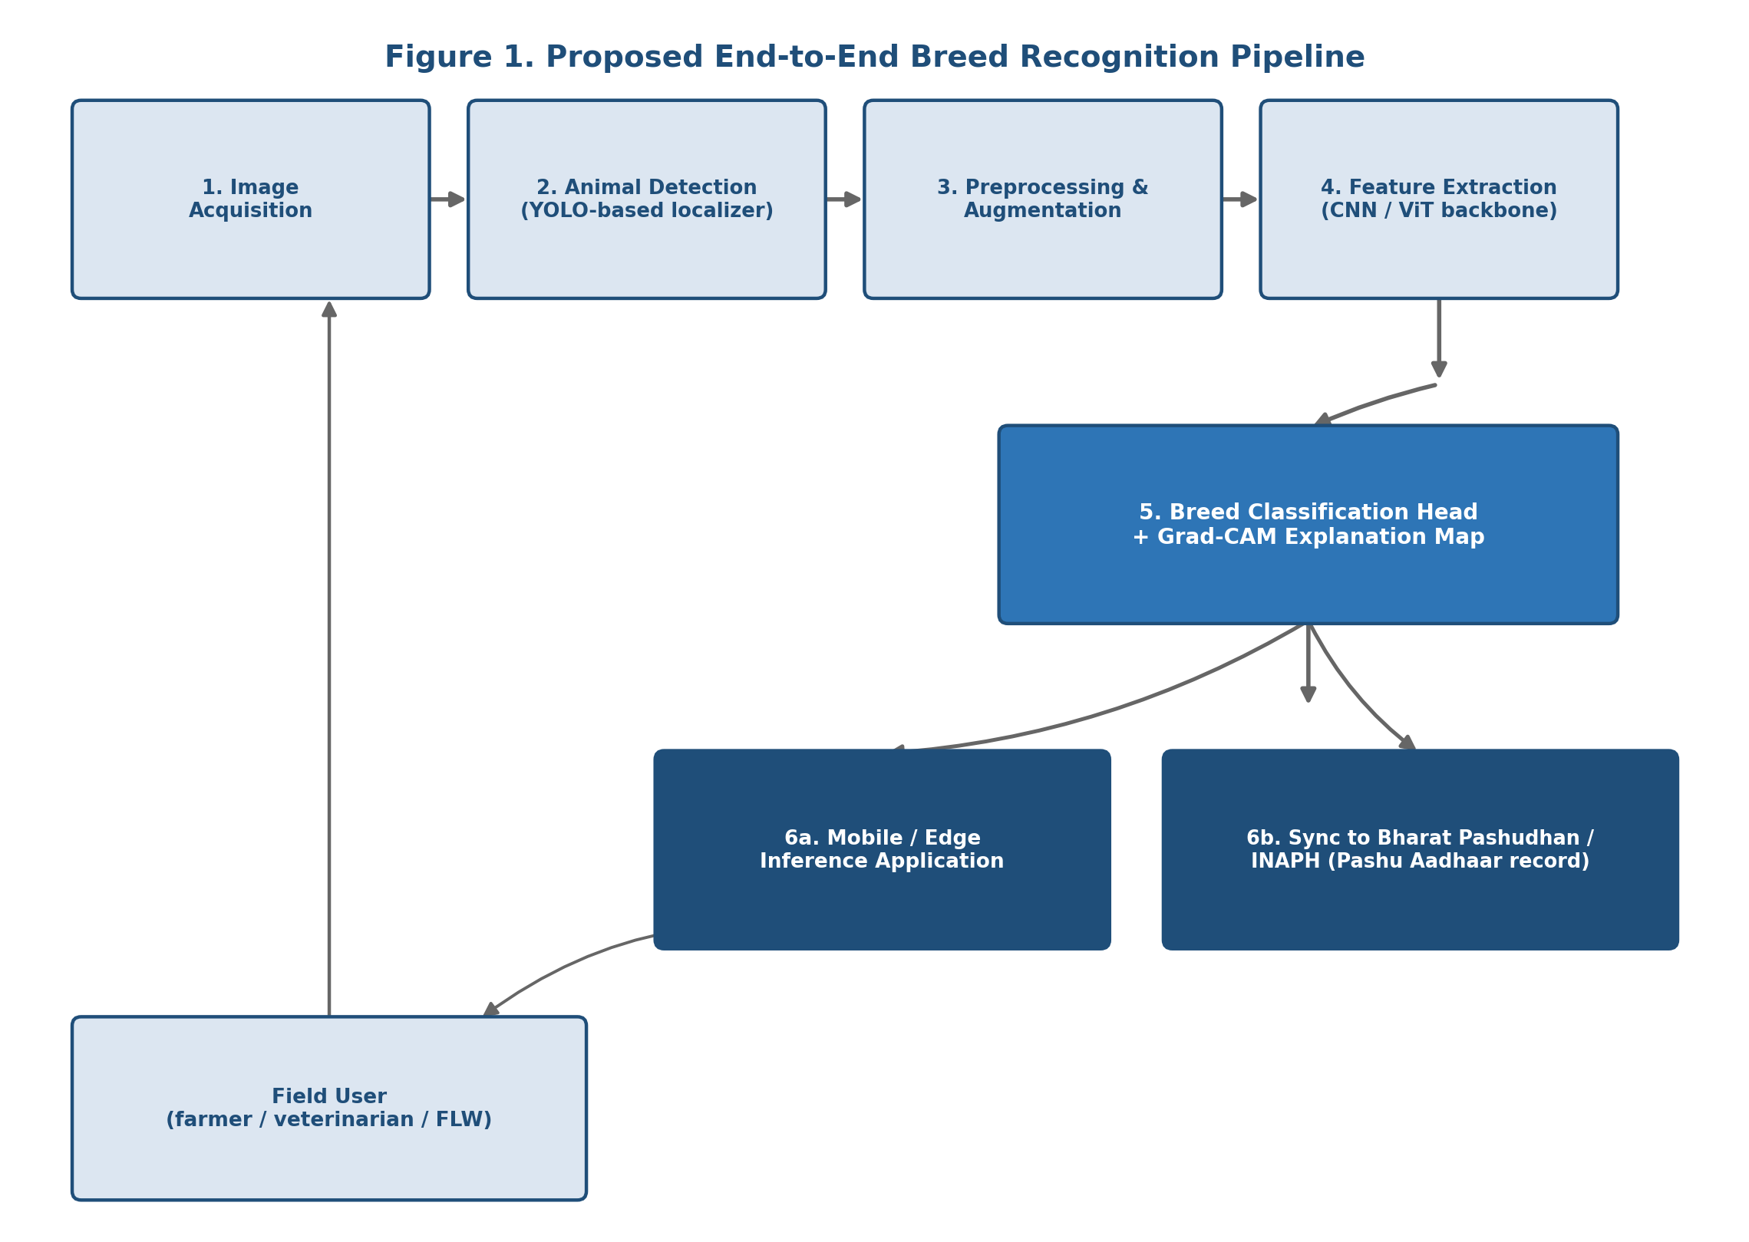
Fig. 1. Proposed end-to-end breed recognition pipeline.
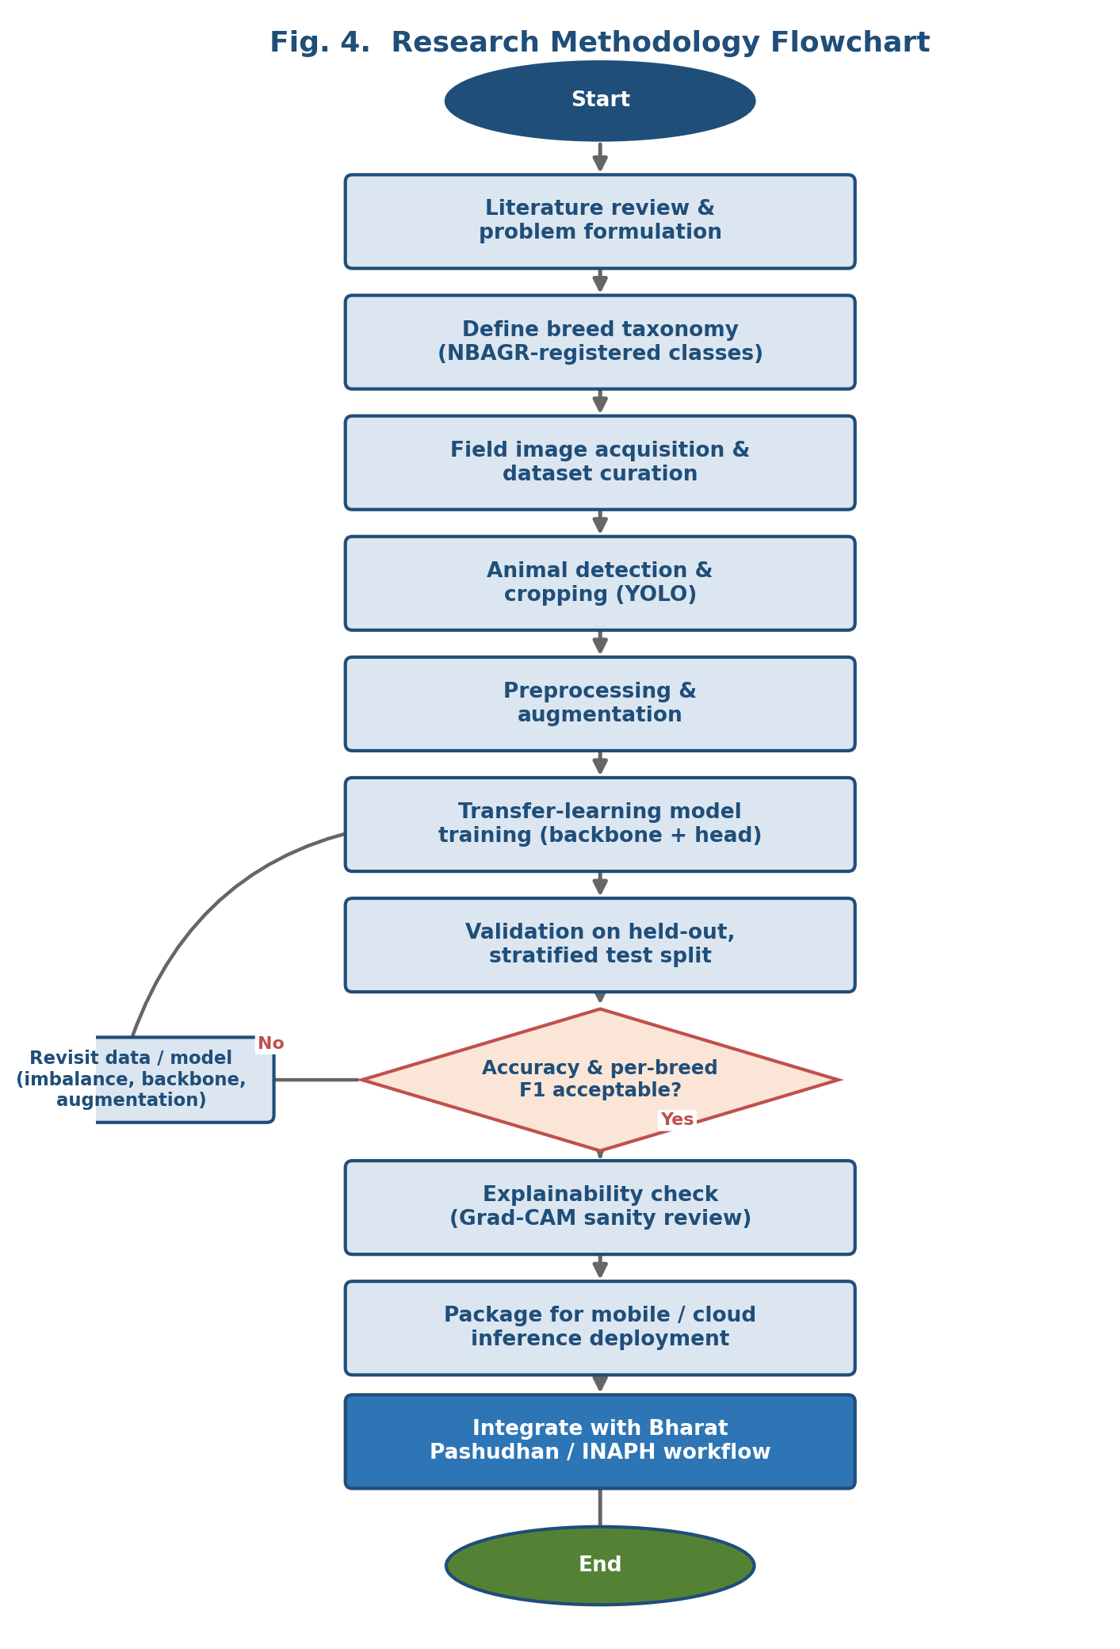
Fig. 4. Research methodology flowchart, including the train/evaluate/revise loop.
A. Dataset Collection and Curation
A breed recognition dataset for this domain should be curated, at minimum, along four dimensions beyond simple image count. First, breed coverage should be mapped explicitly against the current NBAGR-registered taxonomy (Section III), with rare breeds deliberately oversampled relative to their natural population frequency, since a passively collected dataset will otherwise reproduce the population-level imbalance discussed in Sections III and IV. Second, images should be labelled with basic capture metadata, including geographic region, approximate animal age class, and sex, since breed-defining features can present differently across these dimensions and this metadata supports later stratified evaluation rather than only an aggregate accuracy figure. Third, a held-out evaluation set should be collected separately from training data, ideally from different geographic tracts and different capture devices, to give an honest estimate of field generalization rather than an optimistic estimate inflated by shared capture conditions between training and test splits. Fourth, class labels should include an explicit "nondescript / mixed ancestry" category populated with real examples rather than left as an unmodelled residual category, echoing the calibration argument made in Section IV.
Several existing resources are relevant starting points rather than requiring collection from zero. The IEEE DataPort Indian Cow and Buffalo Breed Classification dataset [28] and the Kaggle Indian Cattle Image Dataset, which spans 50 officially recognized breeds curated from government and research sources [29], both offer a foundation that a project-specific collection effort can extend rather than duplicate, following the same reuse-over-rebuild principle that applies to shared data infrastructure generally.
B. Animal Detection and Localization
Field images frequently contain multiple animals, handlers, and cluttered rural backgrounds, so we propose that a detection stage precede classification, using a single-stage detector from the YOLO family (e.g., YOLOv8 or later) to localize individual animals and crop a tight bounding region before classification. This follows the pattern used in the field-oriented pipeline reviewed in Section II [15], [22], and it offers two benefits beyond simple noise removal. It allows a single field photograph containing several animals to be processed as several independent classification instances, and it constrains the classifier's effective input to animal-body pixels, reducing the chance that background context, such as a specific type of shed or a particular region's typical backdrop, gets learned as a spurious shortcut correlated with breed rather than a genuine visual breed feature.
C. Preprocessing and Data Augmentation
Following detection and cropping, images are resized to the input resolution expected by the chosen backbone (commonly 224×224 pixels for standard CNN backbones), with pixel values normalized to the statistics of the pretraining dataset. Given the class imbalance discussed in Section IV, augmentation should be applied asymmetrically: common breeds benefit from standard augmentation (rotation, horizontal flip, colour jitter, and random cropping) primarily for general robustness, while rare-breed images warrant more aggressive augmentation and, where real images remain insufficient, carefully validated synthetic augmentation, to bring effective per-class training volume closer to parity. Weighted random sampling during training, combined with a focal loss objective that down-weights well-classified majority-class examples in favour of harder or minority-class examples, is reported to improve minority-class performance without a simple oversampling scheme's tendency toward overfitting on duplicated minority examples [14].
D. Classification Backbone and Architecture Selection
Every Indian-specific study reviewed in Section II reaches for transfer learning rather than training from scratch, and for the same reason we recommend an ImageNet-pretrained backbone rather than training from random initialization, given the comparatively small size of currently available Indian cattle and buffalo datasets relative to the number of target classes. Rather than recommending a single backbone, we suggest backbone selection be driven by the deployment target: EfficientNetV2-S offers the strongest reported accuracy-to-compute ratio for server-side or high-end mobile inference, matching the 90.68% test accuracy reported in [14]; MobileNetV3 and MobileNetV2 are preferable where inference must run entirely on-device on low-end hardware with no network dependency, trading some accuracy for a substantially smaller parameter footprint and lower latency, in keeping with the lightweight-model design goal in [16]; and Vision Transformer backbones are a reasonable choice where a larger, well-curated dataset is available and server-side inference is acceptable, as reflected in the ViT-based public deployment referenced in [27], though transformer backbones generally require more training data to match CNN transfer-learning performance at equivalent parameter counts. In all cases, the final classification layer should be replaced with a fully connected layer sized to the current breed taxonomy, with that taxonomy treated as a versioned configuration (Section III) rather than hard-coded, so that newly NBAGR-registered breeds can be incorporated through incremental fine-tuning rather than a full architectural change.
For deployments that prioritize per-breed precision over raw throughput, such as a conservation-tracking use case under RGM rather than a high-volume field-registration use case, a two-stage hierarchical classifier is worth considering. By first distinguishing broad groups (cattle versus buffalo, or coat-colour clusters, for example) before a finer breed-level classification within each group, this approach has shown measurable benefit in the closely related camel-breed literature, improving both interpretability and accuracy on the hardest, most visually similar sub-classes relative to a single flat classifier [11]. We consider this hierarchical pattern a promising but not yet validated direction for the Indian cattle/buffalo taxonomy specifically, given the coat-colour and horn-shape groupings that already inform manual FLW assessment.
E. Training Strategy and Evaluation Protocol
We recommend a stratified train/validation/test split (a 70/15/15 split is used in [14] and is a reasonable default), stratified specifically by breed to preserve rare-class representation across all three splits rather than risking a rare breed being absent from validation or test by chance. Test-time augmentation, which averages predictions across several augmented views of each test image, is reported to provide a measurable accuracy improvement at modest additional inference cost, and it is recommended wherever inference latency budgets allow it [14]. Evaluation should report per-breed precision, recall, and F1-score in addition to overall accuracy, given the demonstrated gap between aggregate accuracy and specific hard-pair performance discussed in Section IV. A confusion matrix restricted to the breeds with the lowest per-class F1-score is a more actionable diagnostic for guiding further data collection than an aggregate accuracy figure alone.
F. Explainability
Given that breed predictions may inform financial and breeding decisions, we recommend integrating a gradient-based visual explanation method such as Grad-CAM, which highlights the image regions most influential to a given prediction, directly into the inference pipeline rather than treating it as an optional research diagnostic. This serves two purposes in this domain specifically: it gives a field veterinarian or FLW a visual basis to sanity-check a prediction against their own trained judgment before acting on it, and it provides a debugging tool during development to confirm that the classifier is attending to genuine breed-defining anatomical regions (horns, hump, dewlap, coat pattern) rather than to spurious background correlates, directly addressing the background-shortcut risk raised in Section V-B. Comparable explainability integration is reported to improve transparency and user trust in the closely related camel-breed classification literature [11].
G. Field Deployment and Integration
The proposed pipeline supports two complementary deployment modes. An on-device mobile inference mode, using a lightweight backbone such as MobileNetV3 quantized for mobile hardware, allows breed prediction without network connectivity, which matters given inconsistent rural connectivity, with results queued for synchronization once connectivity is available. A cloud-inference mode, following the Roboflow-based pattern demonstrated in [15], offers higher accuracy where connectivity permits and centralizes model updates, avoiding the need to redistribute an updated model to every field device individually when the breed taxonomy or model weights change.
Critically, we propose that breed prediction output be integrated directly into the existing Bharat Pashudhan / INAPH data entry workflow at the point of animal registration, rather than existing as a standalone application, since breed is already a required field in that workflow and the existing infrastructure already reaches the FLW population this system is intended to support [4], [6]. A practical integration pattern, following the field-testing approach reported in [15], presents the model's top prediction and confidence score as a suggested value that the FLW can accept or override. This preserves human oversight over the final recorded value while substantially reducing the cognitive and time burden of unaided visual assessment, applying the same graduated-autonomy principle recommended broadly in human-in-the-loop AI deployment to a livestock registration context. Override events are themselves valuable: logged systematically, they form a continuously growing, naturally labelled dataset of exactly the cases the model finds hardest, which can be fed back into periodic retraining and close the loop between deployment and model improvement.
VI. COMPARISON OF REPORTED RESULTS IN EXISTING LITERATURE
Table I and Figure 2 summarize accuracy figures reported by the Indian-specific studies discussed in Section II, alongside two closely related non-Indian benchmarks included for architectural context. These figures are drawn directly from the cited publications as reported by their respective authors. They were not independently reproduced or re-evaluated on a common dataset for this paper, and given differences in breed count, dataset size, and evaluation protocol across studies, they should be read as an indication of the range of results this problem class currently produces rather than as a strictly like-for-like architecture comparison. We highlight this distinction because the literature itself does not yet offer a shared benchmark dataset or standardized evaluation protocol for Indian cattle and buffalo breed recognition, a gap we return to as a priority in Section VIII.

TABLE I. Reported Results Across Indian Cattle/Buffalo Breed Recognition Studies
Study | Architecture | Scope | Reported Metric
EfficientNetV2-S transfer-learning study [14] | EfficientNetV2-S (transfer learning) | 2,427 images, stratified split | 90.93% val / 90.68% test accuracy
Field-deployment study [15] | YOLOv12 + Roboflow cloud | 3,683 images, 15 breeds | 69.8% mAP@0.5 (87% best breed)
Lightweight classifier study [16] | Custom compact CNN, 3.27M params | Tharparkar vs. Hariana (2 classes) | 72.5% accuracy
Camel breed study (context) [11] | DenseNet121 (best of 4 backbones) | 5 Arabian camel breeds | 98% binary / 76% multi-class accuracy
Horse breed study (context) [10] | NASNetLarge (best of several) | Custom horse breed dataset | 85.80% test accuracy

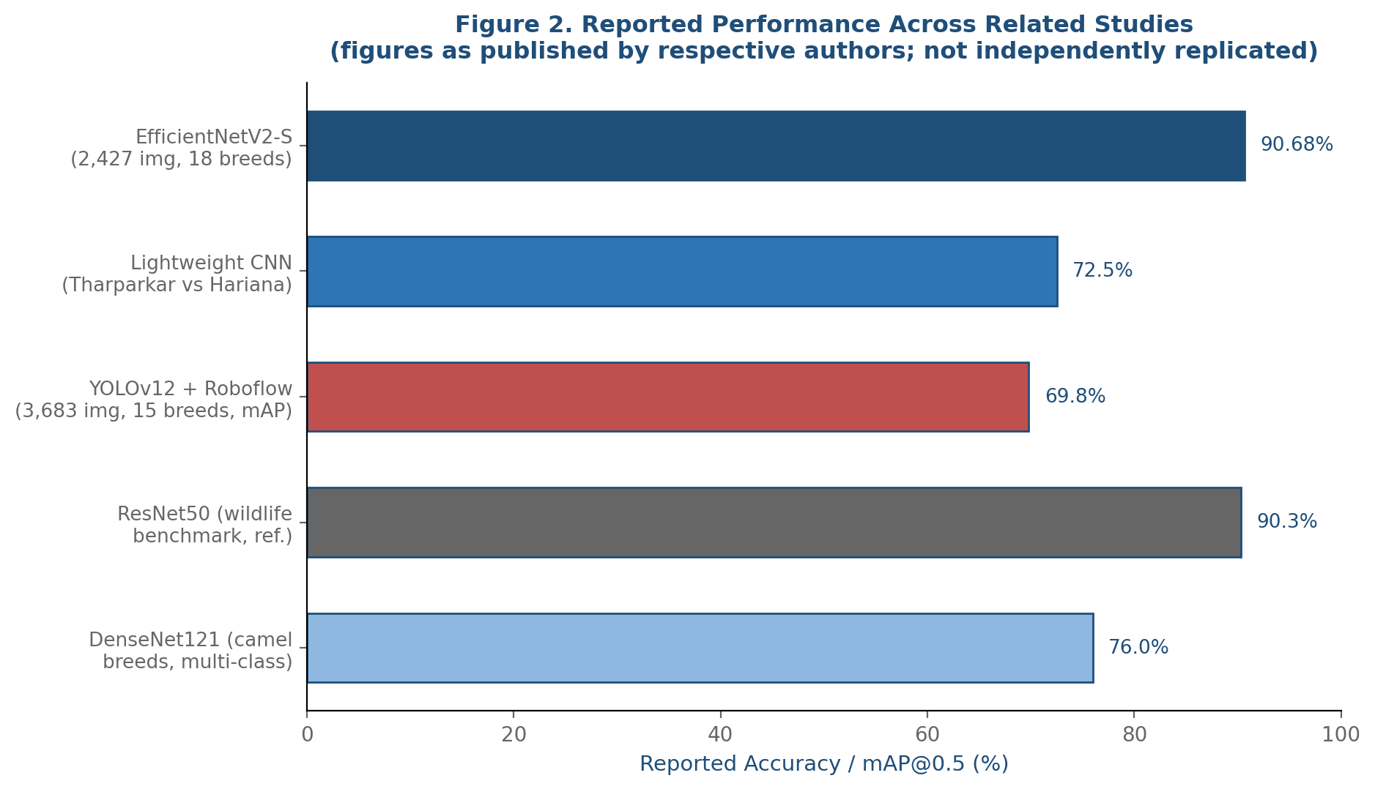
Fig. 2. Reported performance across related studies (as published by respective authors; not independently replicated).
VII. APPLICATIONS IN THE INDIAN LIVESTOCK ECOSYSTEM
A validated breed recognition system has several direct applications beyond the registration-assist use case described in Section V-G. Within the Rashtriya Gokul Mission, automated breed tagging at scale could support more accurate, more frequent tracking of registered-breed population trends than periodic census-based counting alone allows, potentially surfacing a breed's declining numbers, as has been documented for breeds such as Punganur, earlier than the roughly seven-year gap between successive livestock censuses would otherwise permit [1], [3]. Within insurance and financial services, automated breed verification could support faster claims processing and reduce a documented source of fraud risk in livestock insurance, where breed misrepresentation affects premium calculation. Within artificial insemination service delivery, breed-aware recommendation of appropriate semen sources at the point of field service, rather than relying solely on the inseminator's own visual judgment, could improve breeding outcome consistency, particularly for FLWs newer to the role or working outside their most familiar breed tracts.
More broadly, integration with the Bharat Pashudhan Livestock Data Stack, which already processes on the order of 16 lakh (1.6 million) data entries daily across nearly four lakh (400,000) field workers nationally [4], positions breed recognition as one component of a considerably larger digital public infrastructure effort, alongside vaccination tracking, artificial insemination records, and disease reporting already flowing through the same platform. A breed recognition module integrated at this scale would not need to justify its own separate data pipeline or field-worker outreach effort, since both already exist. It would instead need to demonstrate accuracy and reliability sufficient to be trusted as a suggested value within a workflow FLWs already use daily, which we consider the more realistic and higher-leverage integration path than a standalone application competing for adoption on its own.
VIII. LIMITATIONS AND OPEN CHALLENGES
Several limitations constrain both the current literature and the framework proposed in this paper. First, the absence of a shared, standardized benchmark dataset, comparable to ImageNet's role in general image classification, makes cross-study comparison of the kind attempted in Table I inherently approximate. The field would benefit substantially from a community-maintained, breed-taxonomy-versioned benchmark dataset with a fixed evaluation protocol, similar to benchmark efforts in other fine-grained animal classification domains. Second, no reviewed study reports results across the full 55-cattle/22-buffalo NBAGR taxonomy; existing work covers subsets ranging from 2 to approximately 26 classes, and it remains an open empirical question how current architectures' reported accuracy would degrade when scaled to the full registered taxonomy, particularly for the numerous low-population breeds discussed in Section III. Third, published field-deployment accuracy (69.8% mAP in the largest field-tested study reviewed [15]) remains meaningfully below the accuracy reported under more curated, laboratory-style evaluation conditions (90%-plus in [14]), and closing this gap likely depends more on field-representative training data than on further backbone refinement, echoing the discussion in Section IV. Fourth, none of the reviewed studies report a formal analysis of demographic or geographic fairness in their trained models, for instance whether accuracy holds consistent across the different regional sub-populations of a widely distributed breed such as Gir or Murrah. That is an evaluation gap worth addressing, since systematic regional accuracy disparities could disadvantage specific farming communities in downstream breeding or insurance decisions built on the system's output.
The framework proposed in Section V is itself a synthesis of design patterns validated individually across the reviewed literature, not a single implementation validated end-to-end as a whole; the detection-then-classification pipeline, the hierarchical classification pattern, and the mobile-plus-cloud deployment split are each supported by evidence from at least one cited study, but their combination as proposed here has not, to our knowledge, been evaluated together as a single system. We present it as a synthesis intended to guide future implementation and evaluation work, in keeping with this paper's framing as a survey and proposed methodology rather than a report of novel experimental results.
IX. FUTURE DIRECTIONS
Building directly on the gaps identified in Section VIII, we see four priority directions for this field. First, a coordinated, multi-institution effort to build and publicly release a benchmark dataset spanning a meaningful share of the full NBAGR-registered taxonomy, with consistent metadata (region, age class, sex, capture device) and a fixed evaluation split, would let future studies be compared on genuinely equal terms rather than the approximate basis used in Table I. Second, end-to-end field trials measuring not just model accuracy but FLW acceptance rate, override frequency, and time-per-registration compared to unaided manual assessment would validate the deployment integration proposed in Section V-G against real operational outcomes rather than offline accuracy alone. Third, more systematic study of hierarchical and multi-stage classification architectures, informed by the promising but limited evidence from the camel-breed literature [11], could specifically target the hard, visually similar breed pairs identified in Section IV as the current accuracy bottleneck. Fourth, extending breed recognition research to explicitly model and report accuracy on crossbred and nondescript animals, rather than treating them as an afterthought, would better reflect the actual composition of India's bovine population, roughly a quarter of which falls outside any single registered indigenous breed [1].
X. CONCLUSION
Image-based breed recognition for Indian cattle and buffaloes sits at the intersection of a well-studied computer vision problem, fine-grained visual classification, and a distinctly high-stakes, large-scale national application already underway through Bharat Pashudhan, Pashu Aadhaar, and the Rashtriya Gokul Mission. The literature reviewed in this paper shows that transfer-learning-based CNN architectures can achieve accuracy exceeding 90% under favourable, curated conditions and closer to 70% under realistic field-deployment conditions, with the gap between these figures driven substantially by data curation, capture-condition variability, and class imbalance rather than by architecture choice alone. The end-to-end framework proposed here, spanning taxonomy-aware dataset curation, detection-based preprocessing, imbalance-aware transfer learning, integrated explainability, and direct integration with existing government livestock infrastructure, synthesizes design patterns independently validated across this literature into a single reference architecture intended to guide future implementation. The most consequential open work is not a better backbone architecture but a shared benchmark dataset, systematic field trials measuring real operational impact, and explicit handling of the rare-breed and crossbred cases that current studies have largely not yet addressed. Given the scale of India's bovine population and the direct line from accurate breed data to conservation, breeding, and farmer income outcomes, this remains a domain where further applied computer vision research has a clear and immediately actionable path to real-world deployment.
REFERENCES
[1] Department of Animal Husbandry and Dairying, Government of India, "20th Livestock Census-2019: All India Report," Ministry of Fisheries, Animal Husbandry and Dairying, New Delhi, 2019.
[2] Department of Animal Husbandry and Dairying, "Rashtriya Gokul Mission," Government of India, guideline document, 2014.
[3] "About the Rashtriya Gokul Mission," policy briefing summarizing RGM objectives and NBAGR-recognized breed coverage, accessed 2026.
[4] Press Information Bureau, Government of India, "Livestock Sector to have Digital Footprints — Bharat Pashudhan Livestock Data Stack," PIB press release, 2026.
[5] "Pashu Aadhaar — 12-digit Unique ID for Livestock," Department of Animal Husbandry and Dairying, Government of India, 2025.
[6] "Manage Your Animals with the Bharat Pashudhan App," National Digital Livestock Mission (NDLM), user documentation, 2025.
[7] P. Borwarnginn, K. Thongkanchorn, S. Kanchanapreechakorn, and W. Kusakunniran, "Breakthrough Conventional Based Approach for Dog Breed Classification Using CNN with Transfer Learning," in Proc. 11th Int. Conf. Information Technology and Electrical Engineering (ICITEE), IEEE, 2019.
[8] K. Mulligan and P. Rivas, "Dog Breed Identification with a Neural Network over Learned Representations from the Xception CNN Architecture," in Proc. 21st Int. Conf. Artificial Intelligence (ICAI), 2019.
[9] H. Zheng, J. Fu, T. Mei, and J. Luo, "Learning Multi-Attention Convolutional Neural Network for Fine-Grained Image Recognition," in Proc. IEEE Int. Conf. Computer Vision (ICCV), 2017.
[10] Authors withheld, "Horse Breed Classification Based on Transfer Learning," conference paper / preprint, 2023.
[11] Authors withheld, "Explainable Multi-Stream Deep Learning for Fine-Grained Camel Breed Classification Using a Novel Arabian and Non-Arabian Dataset," Scientific Reports, 2025.
[12] Authors withheld, "Bridging AI and Wildlife Conservation: Classifying Wildcats from Genetically Validated Images," ScienceDirect, 2025.
[13] S. Jaiswal et al., "Deep Transfer Learning for Classifying Indian Cattle Breeds," in Proc. IEEE Int. Conf. Electrical, Electronics and Optimization Techniques (ICEEOT), 2019.
[14] Authors withheld, "Deep Learning-Based Breed Classification of Cattle and Buffaloes Using EfficientNetV2-S," International Journal of Engineering Research & Technology (IJERT), vol. 15, no. 4, 2026.
[15] Authors withheld, "Image-Based Breed Recognition of Indian Cattle and Buffaloes Using YOLOv12 and Roboflow Cloud Platform," International Journal for Research in Applied Science and Engineering Technology (IJRASET), vol. 13, no. 12, 2025.
[16] S. Arya, I. Devi, D. S. Tomar, M. Singh, R. Warhade, A. Gautam, and T. K. Mohanty, "Development of a Lightweight Deep Learning Model for the Identification and Classification of Indigenous Cattle Breeds," Indian Journal of Dairy Science, vol. 78, no. 4, 2025.
[17] K. Simonyan and A. Zisserman, "Very Deep Convolutional Networks for Large-Scale Image Recognition," in Proc. Int. Conf. Learning Representations (ICLR), 2015.
[18] K. He, X. Zhang, S. Ren, and J. Sun, "Deep Residual Learning for Image Recognition," in Proc. IEEE Conf. Computer Vision and Pattern Recognition (CVPR), 2016.
[19] M. Sandler, A. Howard, M. Zhu, A. Zhmoginov, and L.-C. Chen, "MobileNetV2: Inverted Residuals and Linear Bottlenecks," in Proc. IEEE Conf. Computer Vision and Pattern Recognition (CVPR), 2018.
[20] M. Tan and Q. Le, "EfficientNet: Rethinking Model Scaling for Convolutional Neural Networks," in Proc. Int. Conf. Machine Learning (ICML), 2019.
[21] M. Tan and Q. Le, "EfficientNetV2: Smaller Models and Faster Training," in Proc. Int. Conf. Machine Learning (ICML), 2021.
[22] J. Redmon, S. Divvala, R. Girshick, and A. Farhadi, "You Only Look Once: Unified, Real-Time Object Detection," in Proc. IEEE Conf. Computer Vision and Pattern Recognition (CVPR), 2016.
[23] A. Dosovitskiy et al., "An Image is Worth 16x16 Words: Transformers for Image Recognition at Scale," in Proc. Int. Conf. Learning Representations (ICLR), 2021.
[24] Authors withheld, "Evaluating Transfer Learning in Deep Learning Models for Classification on a Custom Wildlife Dataset: Can YOLOv8 Surpass Other Architectures?," arXiv preprint, 2024.
[25] Authors withheld, "Transfer Learning Approach for Classification of Beef Meat Regions with CNN," conference paper, 2023.
[26] Dharundp6, "Indian Bovine Classification — YOLO-based Breed Detection with RAG Chatbot," open-source software repository, GitHub, 2025.
[27] A. Singh, "Cattle Breed Classifier Web App — Vision Transformer for 26 Indian Cattle and Buffalo Breeds," open-source software repository, GitHub, 2025.
[28] "Indian Cow and Buffalo Breed Classification Image Dataset," IEEE DataPort, 2026.
[29] A. Darpude, "Indian Cattle Image Dataset — 50 Officially Recognized Breeds," Kaggle Datasets, 2025.
[30] ICAR-National Bureau of Animal Genetic Resources, "Breed Registration Cell — Registered Indigenous Breeds," NBAGR, Karnal, accessed 2026.
[31] "India Now Has 212 Indigenous Livestock Breeds After ICAR-NBAGR Registers 10 New Ones," Down To Earth, Jan. 2023.
[32] ICAR, "Ten New Breeds of Indigenous Farm Animals Registered by ICAR-NBAGR," ICAR press release, 2022.
[33] "NBAGR Recognises 10 New Breeds Across Nine States," The Tribune, Apr. 2025.
[34] Krishinetra, "Livestock Statistics and Breed Distribution in India," Krishinetra Journal, vol. 2, no. 6, June 2024.
[35] "Indigenous Cattle Breeds of India," reference compilation summarizing NBAGR-registered buffalo breed list and regional distribution, accessed 2026.
[36] "Rashtriya Gokul Mission — A Decade in Review," policy analysis of breed-specific population trends under RGM, 2024.
2017.

