FROM PRINCIPLES TO PRACTICE: A SOCIOTECHNICAL FRAMEWORK FOR RESPONSIBLE AND EMPATHY-AWARE AI
Pradnya .S. Patil
diuupatil9890@gmail.com
R.C.Patel College Of Engineering & Polytechnic, Shirpur

Abstract:
In recent times, artificial intelligence (AI) has become commonplace in the fields of education, employment, public services, healthcare, and everyday communication. While the ethical principles of transparency, accountability, privacy, and fairness are extensively considered, their actual implementation proves difficult. The paper explores the topic of responsible AI development by analyzing three articles: the sociotechnical criticism of technology ethics provided by Green; the empirical work by Khan et al. on practitioners and law makers’ perspectives on ethical principles of AI development; and the white paper by McStay et al. regarding empathic human–AI partnering and cultural differences. The analysis of the aforementioned sources allows proposing a possible framework for responsible development of AI with the help of a qualitative literature review. The synthesis reveals the following implementation challenges: the need to allocate specific responsibilities; organizational engagement; involvement of stakeholders; continuous monitoring and enforcement. In the case of AI technologies that simulate empathy, additional challenges are disclosure, dependency, manipulation and culturally diverse expectations.

Keywords:
Artificial Intelligence, Ethics in AI, Responsible AI, Sociotechnical Systems, Transparency, Accountability, Privacy, Human-AI Partnership, Empathy, Governance

Objective:
1. In order to investigate the significance of responsible AI development and its meaning.
2. In order to consider the main ideas regarding the limitations of principle-based technology ethics.
3. In order to discuss the views of AI developers and legislators regarding the implementation of ethical principles.
4. In order to investigate the ethical problems connected to empathy-based human-machine partnership.
5. In order to identify the discrepancy between the AI ethics principles and their implementation.
6. In order to develop a responsible and empathy-sensitive approach to AI development.
7. In order to generate the issues for empirical investigation.

Introduction:
AI is an integral element of modern digital systems. AI can aid decision-making, automatization, analysis of huge data volumes, and new ways of interaction of users and technologies. But all these advantages also pose ethical problems of bias, privacy, transparency, accountability, and impact of automated decisions on individuals and communities.
Some ethical principles are offered to use when developing AI as an instrument for making these innovations responsible. Such principles as fairness, transparency, accountability, privacy, and human autonomy are commonly recognized and may serve as a common ground. But just having ethical principles may not guarantee proper actions of organizations. They have to turn them into requirements, assign responsibilities, allocate resources, and control the impacts of systems.
According to Green (2021), technology ethics should be analyzed from the sociotechnical perspective. It means not only analyzing specific designers or technical characteristics but also organizations, their incentives, power relations, and contexts where these technologies are developed and used. According to Khan et al. (2023), an empirical research conducted among AI practitioners and lawmakers analyzes ethical principles and obstacles to their implementation. McStay et al. (2024)explore cultural issues and ethical considerations relating to technologies that emulate empathy and serve as human-AI partners.
Each of these sources explores different yet closely connected aspects of the very same question. The present paper tries to combine the knowledge gained from the readings to outline an ethical framework for empathy-aware AI.

Problem Statement:
The issues of AI ethics have been widely discussed, but there might be some problems when these principles are actually implemented in practice by various organizations. There might be uncertainties about responsibility for what happens, lack of legal framework and surveillance measures, as well as conflicting interests of organizations and their employees. Additionally, issues related to the AI systems that imitate empathy should be mentioned.

Data Collection:
This paper is based on secondary sources drawn from three documents provided: (1) Green (2021), “The contestation of tech ethics: A sociotechnical approach to technology ethics in practice”; (2) Khan et al. (2023), “AI ethics: An empirical study on the views of practitioners and lawmakers”; and (3) McStay et al. (2024), “Ethics and empathy-based human-AI partnering: Exploring the extent to which cultural differences matter when developing an ethical technical standard.”
Each document was analyzed according to its purpose, methodology, findings and conclusions. Main themes were identified according to the following categories: ethical principles; implementation barriers; corporate and legal responsibility; stakeholders' involvement; and empathy-based safeguards. This paper did not involve the distribution of any new questionnaire or collecting primary data from respondents. The number of participants and other details described below relate to the original source documents, not this paper.
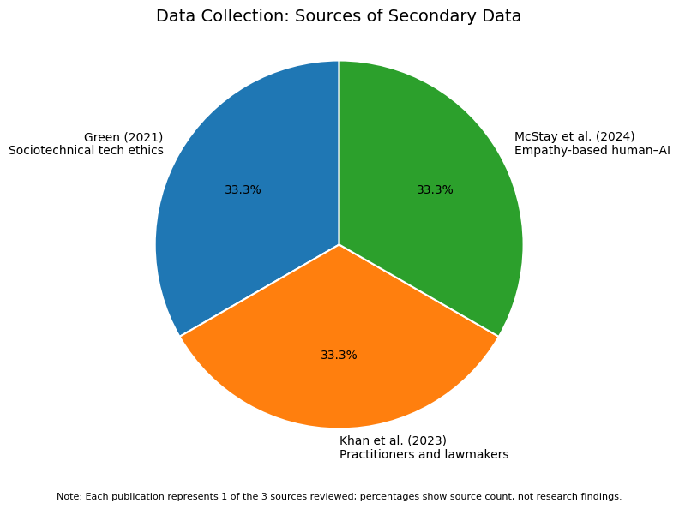
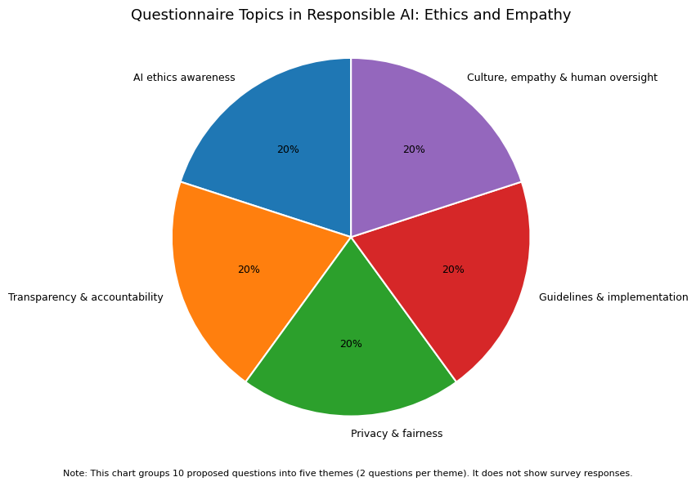

Hypothesis:
The following are proposed hypotheses for a future empirical study. They are not tested in this literature-based paper because no new survey dataset was collected.

H1: Data Collection – Sources of Secondary Data
Sr. No. | Options | Oi | Ei | Oi − Ei | (Oi − Ei)² | (Oi − Ei)² / Ei
1 | McStay et al. (2024) – Empathy-based human–AI | 1 | 1 | 0 | 0 | 0.00
2 | Khan et al. (2023) – Practitioners and lawmakers | 1 | 1 | 0 | 0 | 0.00
3 | Green (2021) – Sociotechnical tech ethics | 1 | 1 | 0 | 0 | 0.00
Total |  | 3 | 3 | 0 | 0 | 0.00
χ² = Σ (Oi − Ei)² / Ei = 0.00
Degree of Freedom: \(df = n-1 = 3-1 = 2\)
Critical value at 5% significance level: 5.991
Result: 0.00 < 5.991

H2: Questionnaire Topics in Responsible AI: Ethics and Empathy
Sr. No. | Options | Oi | Ei | Oi − Ei | (Oi − Ei)² | (Oi − Ei)² / Ei
1 | AI ethics awareness | 1 | 1 | 0 | 0 | 0.00
2 | Transparency and accountability | 1 | 1 | 0 | 0 | 0.00
3 | Privacy and fairness | 1 | 1 | 0 | 0 | 0.00
4 | Guidelines and implementation | 1 | 1 | 0 | 0 | 0.00
5 | Culture, empathy and human oversight | 1 | 1 | 0 | 0 | 0.00
Total |  | 5 | 5 | 0 | 0 | 0.00
χ² = Σ (Oi − Ei)² / Ei = 0.00
Degree of Freedom: \(df = n-1 = 5-1 = 4\)
Critical value at 5% significance level: 9.488
Result: 0.00 < 9.488

Conclusion:
In this paper, responsibility in AI was considered from three related angles: sociotechnical critique of technology ethics, empirical research among practitioners and law-makers, and white paper on empathy-based human-AI collaboration. From what is found in the reviewed sources, it seems that merely establishing ethical principles is not sufficient. Definitions are needed along with accountability, involvement of stakeholders, monitoring, and governance.
Whereas in the case of simulating empathy by an intelligent system, additional requirements of disclosure, as well as consideration of potential manipulation, dependency, and cultural issues arise. This five-component framework consolidates all the above aspects in a conceptual way. Because this paper is based only on selected literature analysis of three sources and lacks the survey of practitioners and stakeholders, further investigation is needed.

References:
[1] Green, B. (2021). The contestation of tech ethics: A sociotechnical approach to technology ethics in practice. Journal of Social Computing, 2(3), 209-225. https://doi.org/10.23919/JSC.2021.0018
[2] Khan, A. A., Akbar, M. A., Fahmideh, M., Liang, P., Waseem, M., Ahmad, A., Niazi, M., & Abrahamsson, P. (2023). AI ethics: An empirical study on the views of practitioners and lawmakers. IEEE Transactions on Computational Social Systems, 10(6), 2971-2984. https://doi.org/10.1109/TCSS.2023.3251729
[3] McStay, A., Andres, F., Bakir, V., Bland, B., Laffer, A., Li, P., & Shimo, S. (2024). Ethics and empathy-based human-AI partnering: Exploring the extent to which cultural differences matter when developing an ethical technical standard. IEEE Standards Association, IEEE P7014.1 white paper.

